Los Angeles, Water, and Harvey Mudd College
An Evaluation of Water Use at Harvey Mudd College

Whitney Buchanan and Ben Tribelhorn
4 May 2007

An Integrative Experience under the advisement of
Theresa Lynn and Richard Haskell

Abstract:
As future leaders in the technical fields, many Harvey Mudd students are developing a commitment to sustainability. In parallel with student groups working on sustainability, we began an investigation of water use on the Harvey Mudd College campus and its impact, both financial and environmental. We present a history of water in Los Angeles and follow the water upstream in order to gauge the financial and environmental impacts. Within this context, we sought to find the distribution of water usage between academic, residential, dining and landscaping at Harvey Mudd College. Through estimates based on water billing data we found that within a 10% error range, the breakdown of end usage on campus is as follows: 15% academic, 21% residential, 3% dining, and 61% landscaping. As this is such a rough estimate we designed a system by which students can evaluate the efficiency of the fixtures in their living space as well as their own usage. During the course of our efforts, we proposed the installation of water meters on the academic cooling towers and on the dining hall to allow for future groups to complete a comprehensive campus-wide water audit. Finally, we motivate conservation efforts and continued focus on water issues by Harvey Mudd students.

Table of Contents

List of Figures 3
List of Tables 4
1 Purpose and Scope 5
2 Los Angeles’ Water: The Triple Bottom Line 6
2.1 California’s Water 6
2.2 Where does our water come from? 7
2.2.1 Los Angeles’ First Imported Water: The Owens River Valley 9
2.2.2 Colorado River Water 12
2.2.3 California State Water Project 13
2.3 Costs of Our Water 14
3 What We’d Like to Know About Water at HMC 18
3.1 End Uses of Water 18
3.2 System and Components 20
4 What We Currently Know About Water at HMC 22
4.1 Total Water Usage 22
4.2 Campus Breakdowns 27
4.2.1 Landscaping 28
4.2.2 Academic Use 29
4.2.3 Dining Hall Use 32
4.2.4 Residential Use 33
4.2.5 Landscaping Use Revisited 36
4.2.6 Final Estimated Breakdown 36
5 On-Going Results and Future Work 37
5.1 Daily Per Person Usage 37
5.2 Recommendations to Refine Resolution of End Uses 39
5.3 New Information Resources 40
5.4 What about those Flush-Less Urinals? 41
5.5 Preliminary Look at the Feasibility of a Cistern System 41
5.6 Future Work Recommendations 42
Acknowledgements 44
Appendix A: California Native Plants Used on Harvey Mudd Campus 45
Appendix B: Water Audit Form 46
Appendix C: Shower Time Audit Form 47
References 48

List of Figures

Figure 2.1: Mean annual precipitation, 1961-1990 7
Figure 2.2: William Mulholland at approximately 50 years of age 9
Figure 2.3: St. Francis Dam before and after the collapse.. 11
Figure 2.4: Map of the California State Water Project facilities 14
Figure 4.1: Historical plot of total campus-wide water usage from 1993 through present 23
Figure 4.2: The updated schematic of water lines and meters for the HMC campus. 24
Figure 4.3: Overlay of meter locations and buildings served on a satellite photo of HMC's Campus. 24
Figure 4.4: Sketch of landscaping on the Atwood Dorm meter 26
Figure 4.5: Historical data for N. Mills Line. 27
Figure 4.6: Total Water Use Data with Eckert, Sparks, Chen Use Removed 32
Figure 4.7: Preliminary results from water audit kits. 35
Figure 4.8 Current and Future Total Campus Water Breakdowns 36
Figure 5.1: Average yearly precipitation in Los Angeles, Death Valley, Berlin, and New York City 38

List of Tables

Table 4-1 Estimates for Academic Restroom Use 31
Table 4-2 Estimates for Academic Lab Use 31
Table 4-3 Estimates of Dining Hall Usage 33

Purpose and Scope

This document has been prepared as a summary of a semester of work looking at water use at Harvey Mudd College. It is intended to serve both as a record of the knowledge gathered, and as a jumping off point for continuation of this work. It is hoped that information garnered through this project may eventually be used to make informed decisions regarding water conservation efforts on campus.
The goal of the project was two-fold. Firstly, we examined the history of water in the Claremont and wider Los Angeles areas in order to put in perspective all of the costs of this resource. And secondly, we wanted to evaluate water usage at HMC, primarily to determine what the end uses of our water are. We wanted to be able to break HMC's total water use into its components: residential, academic, dining, and landscaping uses. However, it quickly became clear that this evaluation was a non-trivial task as metering for water existed only at the aggregate level for the campus. The majority of the work has been to put systems into place by which reasonable estimates of this division of end uses may be determined.
Information gained from this work and the continuation of it should allow HMC to make changes that will have a significant effect on its water usage in the future and not spend time and effort on changes that will have a minimal effect on water usage on campus.

Los Angeles’ Water: The Triple Bottom Line

At under $2.00 for a hundred cubic feet, or one CCF (748 Gal), water is cheap, even here in our dry climate. And, while some argue that the price of water will rise in the near future, it would have to increase nine-fold before HMC's water use rivaled its electricity use in economic cost. HMC paid about $120,000 for the 2005-06 school year, which pales in comparison to the electric bill of almost $1,000,000. So, then why does anyone really care about water usage given that it is so very cheap? The social and environmental impacts of water and the legislation governing water usage in this area were first set up about a hundred years ago, but are still a changing issue of moral and legal debate. Furthermore, water usage on campus is one of the most visible of our resource uses. If we want to become leaders in sustainability, then evaluating and reducing our water usage is an important step.

California’s Water

California is noted for being a large and geographically diverse state. Even here in Claremont, we are approximately equidistant from skiing and surfing. Going along with the geographic diversity is a huge variance in precipitation levels. Precipitation levels vary from more than 140 inches a year in the northwestern portion of the state to less than three inches in Death Valley [,]. As a whole, California receives 200 million acre-feet of water in precipitation yearly (Figure 2.1). 35% of that remains on the ground as runoff, the rest of it is lost to evaporation or transpiration in plants. 30% of the runoff that remains ends up going to salt sinks (including the Pacific Ocean) []. This means that only around 25% of rainfall actually recharges aquifers and flows into rivers. While 80% of California’s water usage occurs south of Sacramento, 75% of our yearly rainfall occurs north of Sacramento. Southern California and the Central Valley use far more water than they could ever hope to produce on their own.
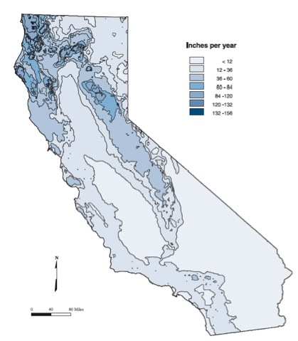
Figure 2.1: Mean annual precipitation, 1961-1990[Error: Reference source not found].

Where does our water come from?
At the lowest level, HMC's water is supplied from Golden State Water Company. Golden State Water Company (GSWC) is part of American States Water Company. Claremont is part of the Foothill District of their Region III service area, which consists of the San Dimas, Claremont, and San Gabriel areas. The water delivered to Claremont is a mix of local groundwater and water imported from the Bay Delta in Northern California []. Claremont does not actually receive water from the Colorado River as the lines that bring Colorado River water into the region are located at a lower elevation than Claremont and the cost of pumping it up is prohibitive.
The Six Basins Watermaster allocates the pumping rights for the local wells that Golden State Water Company uses to provide the local groundwater for the mix. Many of the wells used for our local ground water are owned by GSWC, but not all. For example, Pomona College owns two wells. They sell the water back to GSWC. As a result, Pomona College pays only $0.20/CCF, nine times less than the rest of Claremont [].
The aquifer that the local groundwater comes from is recharged primarily at the spreading grounds below the San Antonio Canyon Dam (on the way up to the Baldy ski lifts). This means that most of the local water here in Claremont comes from snow pack on Baldy. Conscientious management of the aquifer is critical to its endurance. Consistently drawing more water than is recharged every year can lead to the destruction of this water source []. The Six Basins Watermaster is charged with overseeing pumping rights, which includes the responsibility of controlling the amount of water that is removed from the aquifer each year.
The rest of Claremont’s water is purchased by GSWC from the Metropolitan Water District (MWD). The MWD oversees water importation for the L.A. area and gets the majority of its water from the Colorado River and the State Water Project.

Los Angeles’ First Imported Water: The Owens River Valley

How a huge metropolitan area ended up where it is, in the middle of an arid region, is the story of a burgeoning nation’s insatiable appetite for expansion. How that metropolitan area ended up with enough water to survive is, to a large extent, the story of one man. William Mulholland, a Dubliner born in 1855, began his engineering career working as a ditch tender for the Los Angeles City Water Company in 1878 (Figure 2.2). By 1904, Mulholland was in charge. It was through the Los Angeles City Water Company that Mulholland met Fred Eaton, whose family founded Pasadena. Fred Eaton was probably one of the few people in L.A. that had seen the Owens River valley and he envisioned it as the savior of L.A.
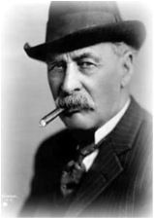
Figure 2.2: William Mulholland at approximately 50 years of age [].

Together, Mulholland and Eaton orchestrated the appropriation of the Owens River. They did so by purchasing water rights as quickly as they could up and down the Owens River. All of the measures they took were legal, though many of them were unscrupulous. The end result was that Los Angeles got enough water to support a million people, and the Owens River Valley, a thriving agricultural haven, would slowly be turned to a dust bowl. The building of the aqueduct from the Owens River to Los Angeles resulted in the annexation of the San Fernando Valley. This made Los Angeles the largest city in the world in terms of geographic area, and provided it with enough wealth and political power to continue to accrue the water it needed to grow. The Los Angeles Aqueduct that brought the Owens River water was completed in 1913. By the early 1920’s it was clear that more water would be needed and Mulholland began lobbying for an aqueduct from the Colorado River. Mulholland is credited as the inspiration for the founding of the MWD, the organization that would eventually complete such an aqueduct, in 1928, the same year as the collapse of the St. Francis Dam, which ended his career [].
The location of the St. Francis Dam was, to a large extent, the result of a falling out between Mulholland and Eaton. Droughts had made it clear that Los Angeles needed not only the flow from the Owens River, but the ability to store it as well. Eaton owned a reservoir site that would solve the water storage problems of the Los Angeles Aqueduct with the construction of a 140 ft dam. The trouble was, Eaton wanted $1 million for the land and Mulholland refused to pay. Instead of paying Eaton, Mulholland decided to increase the size of the St. Francis Dam that was already under construction. When the reservoir behind the dam reached capacity, it began to leak. The water it was leaking was brown with the soil of the surrounding abutments.

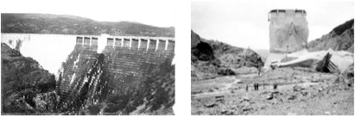
Figure 2.3: St. Francis Dam before and after the collapse. The center portion that remained standing was referred to as the ‘Tombstone’ [].

On March 12th, shortly before midnight and hours after Mulholland had inspected the dam, the abutments failed and the dam collapsed (Figure 2.3), unleashing its 11.4 billion gallon capacity down the Santa Clarita valley. Five hours later the flood reached the ocean some 50 miles from the dam site. Though Mulholland was not found criminally liable for the failure, the collapse of the St. Francis Dam ended his career [Error: Reference source not found].
While the St. Francis Dam no longer plays a role in water in Los Angeles, the story of its construction and failure provides a example of the attitude that was taken in bringing water to the area. Mulholland was a man with a vision and a man with a passion. His passion was for Los Angeles and the growth he envisioned it could attain. Like many men with passions, he did great things, but he also overlooked many consequences of his actions. This attitude continues to dominate water issues in southern California, and only in recent years has it begun to change.
In 1997, the Department of the Interior identified 11 species that have been threatened or endangered by the destruction of habitats in the Owens River Valley and proposed recovery plans for these species []. In 2006, Los Angeles rerouted water so that for the first time in nearly 100 years, water flowed into the lower Owens River Valley []. Southern California’s attitudes towards water and our entitlement to it (or lack thereof) are very slowly starting to change. But, 100 years of aggressive policy has already put into place systems and ideas that are less than ideal.

Colorado River Water

Probably the most well known source of California’s water is the Colorado River. A small, dirty, and unpredictable river, the Colorado is an unlikely celebrity. In 1922, Nevada, Arizona, California, Utah, New Mexico, Colorado, and Wyoming sat down to negotiate the Colorado River Compact. They divvied up the river’s flow for two basins, the northern including Colorado, Utah, Wyoming, and New Mexico, and the southern including the rest. They also left an allocation of water for Mexico. However, none of the individual states could come to an agreement to ratify the compact. For example, California’s ratification was contingent upon the construction of Boulder Canyon Dam (which would become Hoover Dam) and the All-American Canal and Arizona wanted the southern basin to agree to the division of its allotment before it would ratify. In 1928, Congress finally took control and authorized Boulder Canyon Dam and the All-American Canal and limited California’s diversion to 4.4 million acre-feet a year. The rest of the allocations of the original compact stood. Unfortunately, those original allocations were based on the Bureau of Reclamations estimate of the Colorado’s annual flow of 17.5 million acre feet a year. In 1953, a hydrologic engineer by the name of Raymond Hill pointed out that since 1930, the Colorado had only averaged 11.7 million acre-feet a year. No one had noticed so far since most of the states involved in the pact did not have the resources or the need to draw their full allotments, except California, which thanks to its wealth and growth on the back of the Owens River water had built an aqueduct to harvest the Colorado and was pulling its full allotment and itching for more of Arizona’s unused water rights. Currently, California is still the only state that pulls its full allotment; in fact, we are pulling more than our allotted 4.4 million acre-feet. The missing 5.8 million acre-feet has been the cause of seemingly countless legislative battles and engineering projects since []. It is important to note, that while legislative battles rage here over which states get how much water, Mexico is also dependent on the flow of the Colorado, and being at the end of the river is the most likely to be overlooked in allocations.
Beyond the social and political conflict that surrounds water from the Colorado, diversion of the river has environmental costs. In its natural state, the Colorado would switch from riverbed to riverbed every couple of years, replenishing habitats and ecosystems along the way. Now that a large portion of the river is diverted, complex and delicate environments like the Salton Sea (located east of San Diego) that once depended on the Colorado to replenish and refresh them are dependent upon humans to conserve them, or else they will vanish [Error: Reference source not found].

California State Water Project

The California State Water Project is a large aqueduct system that serves to bring water down from northern California to the more arid south. In 1960, the bond measure to fund the project was passed, despite opposition from northern California. The first wave of construction was completed by 1973, and an additional phase of building was finished in 2003. The State Water Project (SWP) today includes a 444-mile-long aqueduct that runs through the Central Valley, 33 storage facilities, 21 primary reservoirs, 26 pumping plants, and 7 power plants; the Project provides water to 29 separate water agencies (Figure 2.4). As of the end of 2001, over $5.2 billion had gone into the construction of the SWP []. Based on our understanding of data provided in Bulletin 132 (a state published document on the operations of the SWP) $700 million in taxpayer dollars go to fund the project every year [].

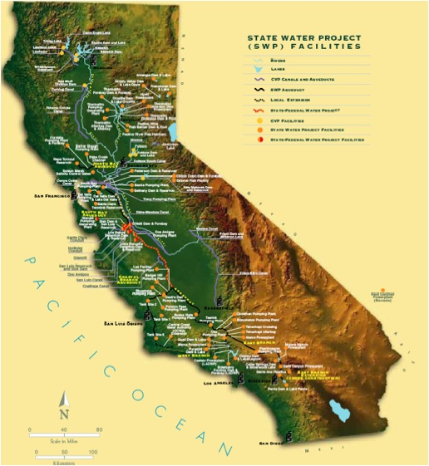
Figure 2.4: Map of the California State Water Project facilities [].

Costs of Our Water
Each of the four main sources of LA’s water carries with it more than its direct financial cost to customers. Despite the fact that Claremont does not directly use water from the Owens or Colorado rivers, we use water from the MWD which controls distribution of all of those sources, and so the more we use, the more is drawn from all the sources.
The groundwater we pump has to be replenished by water from the spreading grounds. As is frequently done to manage water for human consumption, a dam was built, which changes the state of the ecosystem in unpredictable ways. Furthermore, the more we pump out of the aquifer, the less water remains as surface water to refill other creeks and ponds.
Ground and surface water are important resources for more than just city consumption and irrigation. For example, in the Amargosa Desert of Nevada the Devil’s Hole Pupfish (C. diabolis) makes its home in the shallow pools that are in danger of being depleted by loss of ground water being siphoned away for irrigation. C. diabolis was designated an endangered species in 1967, and in 1976 was the source of debate in water rights litigation in the Supreme Court case Cappaert v. United States. Clearly the cost of water has a broader environmental cost for other species as well as for the human populations of those regions [].
The diversion of the Owens River water has obvious social consequences, in that it ruined an entire region. The populations of the Owens River Valley today are subject to dust storms laden with pollutants that blow off of the now dry Lake Owens. These pollutants include a number of heavy metals and salts that are known to cause significant health problems for residents in the region [].
The Colorado River would face extinction if everyone were allowed to pump as much as they wanted from it. It was the natural source for the Salton Sea, a delicate and important eco-system east of San Diego, which is now dependent on human maintenance. As a result of damming practices and water use on the Colorado, only a very small portion of the Colorado still reaches the ocean. Not only that, but unrestricted use of the river here places those downstream of us in jeopardy. The question of whether or not we have more right to the water because we are bigger or growing faster is one that has been the butt of much legislation.
While much of the environmental damage has already been done, efforts can be made to restore the previous states of various areas. It is hoped that by reintroducing water flow to the Owens River Valley that the grassland ecosystem that once existed there may eventually return. This may or may not work, but changing our attitude towards water and the environment is the only way that we can hope to reverse past damage and prevent future destruction.
The costs of water are not equally distributed socially or environmentally, but they are also not equally distributed economically. The State Water Project has been a large burden on taxpayers over the past 40 years, with those using the water not necessarily being the ones to pay for it. Furthermore, the energy cost of getting water here from Northern California is not insignificant. It is partially mitigated by the energy production from dams along the way. But, there is a net positive energy cost to get water to southern California of about 7.3 kWh/CCF. The true energy cost is actually larger as this number does not include the energy costs of purifying the water, distributing it locally, nor treating it (i.e. as sewage), as those processes occur in water regardless of its original source [].
No matter where it came from, once the water gets to southern California it has to be purified and distributed. The energy cost of these two processes is approximately 1 kWh/CCF. Finally, any indoor use of water must be treated once it is used. This uses about 1.5 kWh/CCF [Error: Reference source not found]. None of these numbers is particularly large; however, when summed over all the water that the SWP provides, it turns out that the SWP uses approximately 3.6 x 10⁹ kWh more than is produced by its dams every year. That’s enough to run Harvey Mudd College for 400 years.
All told, the cost of water in Southern California goes far beyond the price charged by GSWC. Since the State Water Project is funded primarily by taxpayers, only a minimal portion is paid by the consumers. GSWC charges $1.76 per CCF plus a service charge based on the meter size []. This barely covers the pure electrical cost of pumping and treating the water, which means that the infrastructure is being paid for by taxpayers. Interestingly enough, although sewage is generally charged by water usage, HMC pays on a per student basis. Per Claremont Municipal 13.08.010 the charge is $0.34 per student per year []. At this small expense the infrastructure and processing costs are clearly being paid by the state. For individual consumers determining the value of water conservation efforts, the environmental and social ramifications must be considered as well as the economic costs.

What We’d Like to Know About Water at HMC

The first step in evaluating water usage on Harvey Mudd’s campus is to determine what information is important to find out. In order to do this, let us consider the reasons for wanting to know how we use water. By far the largest motivator for a project of this sort is eventual conservation, but recommendations for conservation efforts have to be conscious of the low economic cost of water if they are to be adopted. While there are many methods for measuring or reducing water consumption, many of them are more expensive than may be economically warranted by the cost of water. The social and environmental motivations will go only so far in convincing interested parties to invest money in water issues. Thus, the goal of this project was not only to determine where and how we use water, but also to identify the most economically efficient ways in which our knowledge can be improved or our water consumption reduced.

End Uses of Water

At the beginning of the semester, most of what was known about water on campus could be characterized as heuristic observation. While these observations give good indications of where to look and what to examine, a more quantitative analysis is needed in order to make recommendations for an effective water conservation program. For example, a common perception among students, faculty, and staff is that the sprinkler system is very wasteful. We need to determine if that is in fact the case, or if that perception is simply a product of visibility rather than reality. Similarly, much has been made of the installation of flush-less urinals on the academic end. However, no indication was made regarding whether or not the savings from this modification constituted a significant portion of HMC’s total water usage. Of course, from an environmental standpoint, any reduction in water consumption is a positive, but there is another factor to be considered. Assuming that only a fixed amount of money is available to be spent on evaluation and conservation efforts, this work hopes to ensure that it is spent in the most beneficial way.
Understanding the end uses of water would also allow us to make educated decisions regarding various sustainability options. For example, if HMC were ever to undertake a large water project like the installation of cisterns, then knowing how much of our water could come from unfiltered rainwater would be an important factor in both viability and design decisions.
The obvious first step is to find out how much total water is used on HMC’s campus. Before we can begin to break it down or identify problem areas, we simply need to know the aggregate amount of water that is pumped onto HMC’s campus every year. Beyond total supply, it becomes interesting to know where that water goes. End use break down of water usage can identify areas in which conservation will be the easiest or the most effective. In terms of this goal, we identify four main end uses of water: residential, academic, dining, and landscaping. Residential use consists of water used in the dorms by student residents. This use should consist primarily of shower, toilet, drinking, and miscellaneous washing tasks. Academic use is defined as water used in the academic and administrative buildings, with primary uses being restrooms, labs, and air conditioning. Dining use consists of water used in the preparation of food and dishwashing at the dining hall. Finally, landscaping use consists of water used for the irrigation of the landscaping throughout campus.
There are several reasons for finding out what the end uses of water are on HMC’s campus. The most prominent is to be able to identify problems or anomalies that may present opportunities for savings with minor changes. Also, the ability to identify the largest users of water will aid in determining where conservation efforts may be most effectively spent. Sewage is another reason to try to determine the end uses of water. In many places, sewage charges are based on the total water used. This is based on the reasoning that what goes in must come out. However, a campus that uses much of its water for landscaping that isn’t going back into the sewers may not need to be charged sewage for that water. Unfortunately, as noted previously, HMC is not charged by use for sewage, so this option is not available to us. Knowing how much of our water needs goes to indoor use and therefore needs to be treated will still help us determine the full cost of our water usage since sewage treatment also has financial and environmental costs, even if these are not passed on to us as an institution.

System and Components

A good understanding of HMC’s water delivery system is required in order to determine the end uses of water. This includes the irrigation systems as well as the lines themselves and the metering situation. HMC recently underwent an overhaul of the irrigation system in conjunction with a clinic project on native landscaping techniques in 2000-2001. The clinic project looked at the evaporation and transpiration losses of plants as well as climate data in the region and made recommendations for a more water conscious landscaping program. The clinic team planted and metered a test garden just west of Atwood dormitory, which has served as a model for the new landscaping throughout much of campus. At that time, the team made recommendations regarding the new irrigation system, but no formal analysis has been made since it was installed. However, Mike Barber of HMC’s Facilities and Maintenance suggests that savings have been on the order of $30,000 per year based on the ratings of the sprinklers used and the replacements. The metering system and the water lines are crucial to understanding where the water comes from and where it goes. Currently, HMC has only meters installed by the water company for billing purposes. The locations of these meters and the accurate identification of what they service is the first step in identifying the end uses of water.
Although for this project we only separated water use into four categories, a major use of water at HMC are the cooling towers. In the future these should probably be a separate category. The cooling towers are part of the air conditioning systems for all of the buildings with central air: Parsons, Olin, Keck, Jacobs, Libra Complex, Kingston, Thomas Garrett, Platt, South, Linde Activities Center, Case, and Linde. HMC uses cooling towers that function based on evaporative cooling and so this may be a significant source of water usage. According to a report from the U.S. Department of Energy and the National Energy Technology Laboratory, evaporative cooling varies in the range of 10-30% evaporative loss from the circulation system []. Unfortunately, we have not been able to make independent estimates for the loss by the HMC cooling towers, so we have suggested metering the academic cooling towers separately.

What We Currently Know About Water at HMC

Of the things we’d like to know about HMC’s water usage, some are easy to determine, but others are less readily available. Significant progress was made during the course of this work in the gathering of knowledge regarding water usage on HMC. However, there is much that remains to be found.

Total Water Usage
Total water usage for Harvey MUDD was readily available through Tom Shaffer in Facilities and Maintenance (F&M). We were able to obtain aggregate billing data by meter for the campus back through 1993. A plot of the total water usage for the campus can be seen in Figure 4.5. As can be seen from this graph, total campus water usage has been around 60,000 CCF for the past several years. This is equivalent to about 45 million gallons of water. Conversations with F&M have indicated that the small peak in 2003 can likely be attributed to the construction of Sontag Dorm, and that the rise last year may be due to the start of operations at the new dining hall. Tom Shaffer indicated that the new dining hall (Hoch-Shanahan Dining Commons) uses significantly more water than Platt Campus Center did when it functioned as the dining hall.
Ideally, this total usage will be broken down into end uses. The billing data we obtained from F&M was broken down giving us the water used on each meter on campus. This provided us with a starting place in trying to separate out the various end uses of water. Unfortunately, the meter numbers listed on the billing data did not correspond to the meter numbers listed on the CAD drawing of the water lines on file with F&M, the meter numbers also changed on the billing data in the mid 1990’s. We were also informed at this time of a couple of other schematic errors in the CAD drawing regarding the placement of lines to some of the buildings. Tom Shaffer toured the campus with us, and helped us to identify the locations and meter numbers of the meters on campus. We then updated the CAD drawing so that the schematic is correct and the meter numbers match the currently billed numbers. The updated CAD drawing can be seen in Figure 4.6.
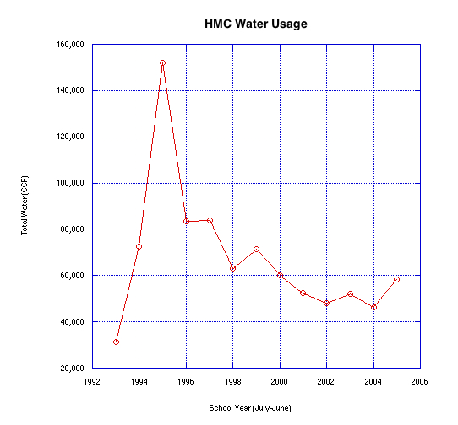
Figure 4.5: Historical plot of total campus-wide water usage from 1993 through present, as determined from billing data.

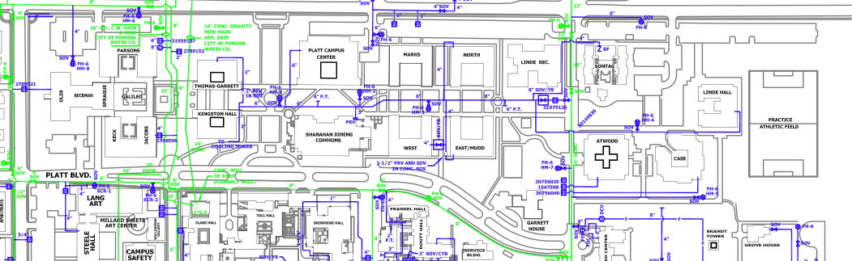
Figure 4.6: The updated schematic of water lines and meters for the HMC campus.

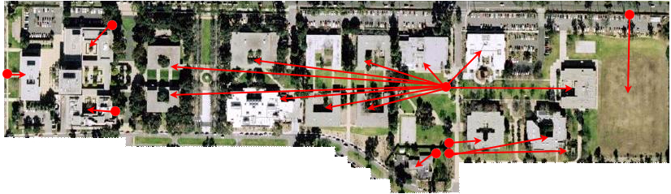
Figure 4.7: An overlay of meter locations and buildings served on a satellite photo of HMC's Campus.

In Figure 4.7, you can clearly see the meter locations and which buildings they serve. The placement of the meters on HMC’s campus is central to determining water usage. The ideal scenario for determining end usage of water would be a meter on each building. This however, is not the case as the meters were installed exclusively for billing purposes. Notice first the meter on the line that spurs off west of N. Mills (N. Mills line). This line, and therefore the meter placed on it, accounts for the water usage of 11 buildings: Thomas Garrett, Kingston, Platt, Hoch-Shanahan, West Dorm, East Dorm, South Dorm, North Dorm, the LAC, Sontag Dorm, and Linde Dorm. This line also serves a large part of the irrigation for the section of campus west of N. Mills Ave and east of the sundial. Needless to say, this does not lend itself well to the separation of water into its end uses. In fact, the only dormitory that is on a meter in relative solitude is Atwood. There is some landscaping on that meter as well, but it is limited to the concrete planters around the dorm itself as can be seen in Figure 4.8.
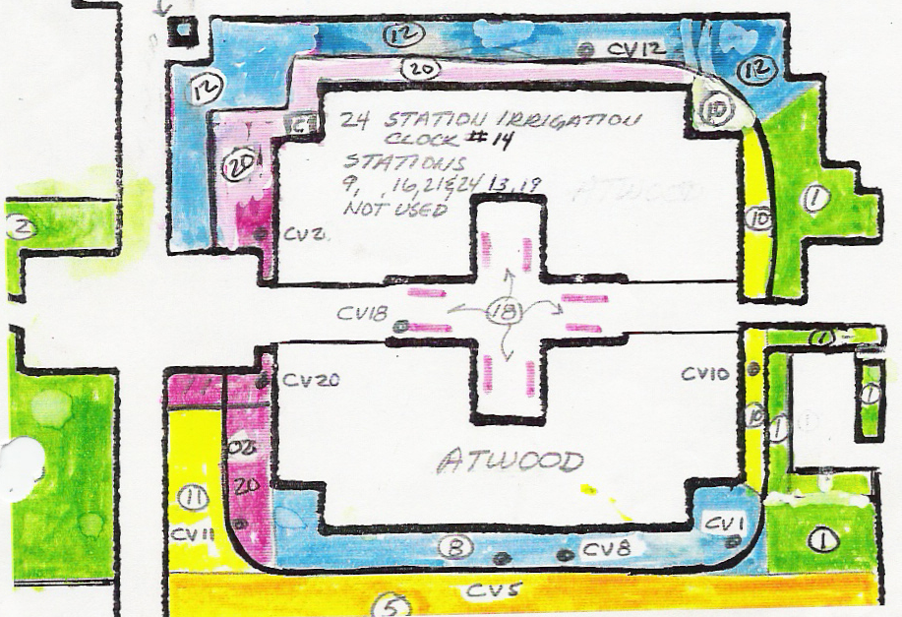
Figure 4.8: Sketch of landscaping on the Atwood Dorm meter

The large peak that is exhibited in Figure 4.5 in 1995 has been attributed to a leak in the North Mills Line after conversations with F&M. A plot of the historical data for the North Mills line can be seen in Figure 4.9. This data shows a peak in 1995 that is correlated with the peak in the total campus usage. In Claremont, leaks in water lines are particularly problematic because of our soil conditions. The natural soil in this area is very sandy. This means that leaks in lines are much more likely to percolate downward than if we had clay soil (in which case they would be much more likely to bubble up). This downward flow of the leaking water makes identifying the leaks difficult.

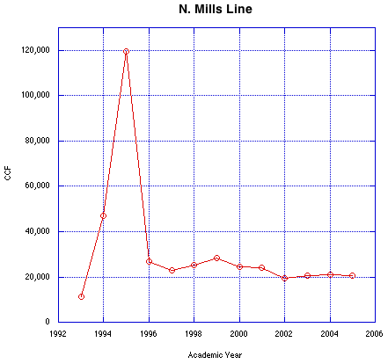
Figure 4.9: Historical data for N. Mills Line. Note the peak that corresponds with the peak in total campus usage.

Campus Breakdowns
As mentioned previously, the four end use categories that we want to be able to differentiate are academics, dining, dorms, and landscaping. The most natural way for us to arrive at these breakdowns is to estimate the first three and assume that the remaining use goes to landscaping. We decided to do it this way because although we suspect that flow data exists for much of the campus irrigation system, we were unable to obtain it.

Landscaping
The somewhat limited landscaping data we do have suggest that a percentage of total water usage well over 50% is not unreasonable. However, despite the large percentage that goes to landscaping, our irrigation system and landscaping is really quite reasonable for this region.
Often, the first things people notice about water usage at Harvey Mudd are the sprinklers on the grass up and down the middle of campus. These sprinklers are among the few of their kind left on campus, and while they are not always perfectly aligned, they are pretty close. Often overlooked are the large areas that have been transitioned to drip lines and native plantings since the recommendations of the 2000-2001 academic year clinic project []. The clinic project looked at evapotranspiration in plants to determine how much water they actually need as a function of weather. The clinic team’s test garden across from Atwood Dorm has served as a model for much of the landscaping renovation on campus. Also, in response to the clinic project’s results, Harvey Mudd installed a Rainbird Weather Station (Model number WS-PRO-PH) which tracks temperature, humidity, precipitation, and wind and controls the sprinklers across campus accordingly. The whole system is maintained and operated by Mike Barber of F&M.
Mike Barber is also responsible for the landscaping on campus. Many of the changes are being made according to a master plan drawn up by Bob Parry in 2001. A list of the native plants that Mike has been using across campus can be found in Appendix A. Star jasmine is being used to replace the very thirsty ivy in many areas. The undergrowth that used to surround the oak trees in many locations on campus has been removed, both because it was heavy water use, but also because these particular trees are much healthier without the growth around their roots. Many of the pine trees around the inner dorms are scheduled to be removed as well. This is not necessarily because pine trees in general need a lot of water, but because of the threat of the bark beetle. While conifers are typically fairly low water plants, keeping them wet enough to keep them safe from the bark beetle uses quite a bit of water. With regard to the large patches of grass that so often get cited as a water faux pas, they are here to stay. The lawn stays as it serves many purposes to the college. A day does not go by that there aren’t students playing Frisbee, or throwing a ball around on them. Classes get held out on the grass and students study and picnic on the grass. Furthermore, if that grass were to be removed, campus would be a lot warmer in the summer and much more unpleasant to walk down or be around. In terms of the landscape master plan, the ‘green belt,’ as its called, down the center of campus, as well as dorm courtyards and a couple other areas are marked as sacred areas that will not be modified to California native landscaping. Other locations of grass, such as the large swath in front of Olin, are also slated to remain unchanged in the plan as they serve as a public face for the college.
While we were not able to acquire solid numbers for irrigation usage, it is thought that the general trend of decline in the total water usage (Figure 4.5) since 2001 has been due primarily to the installation of the new irrigation system and landscaping. If you further consider that the Eckert, Sparks, Chen lab (which will be discussed in further detail in the next section) came online about that time period, the probable water savings due to the landscaping changes are quite significant.

Academic Use
Academic usage consists primarily of lab use, restrooms, and cooling tower usage. Luckily we know the usage for the majority of academics through three meters: Olin, Parsons, and Jacobs (see Figure 4.6). The only problem is that each meter also has landscaping coming off of it. The cooling towers that serve Parsons, Olin, Jacobs and the Libra Complex pull water off of the Jacobs meter, so the Olin and Parsons meter are free of cooling tower water. However, both the Olin meter and the Parsons meter account for a large amount of irrigation area: the Dartmouth frontage area, and everything between Galileo and the sundial respectively. So we can only use numbers from these meters to make sure that our estimates are reasonable in order of magnitude.
Table 4-1 shows our estimates for restroom use, which is based on an estimates enrollment of 720 students 65% of which are male and a known faculty/staff population of 280 (we assume 50/50 gender split). We take into account the estimated frequency with which men use flush-less urinals as well as the estimated frequency of bathroom use.
The other major use of water in academic buildings is use in labs. We are aware of the Eckert, Sparks, Chen lab that accounts for a very large portion of total campus usage. Table 4-2 shows this lab usage and estimated common lab usage. Beyond the Eckert, Sparks, Chen lab, we estimate that the primary water use occurs in chemistry and biology labs. For a given section of a chemistry teaching lab, we made the assumption of a faucet flow rate of 2.5 Gal/min for an average sink (as an overestimate from a dorm survey) as well as about 3 minutes of flow per lab group with an average of 10 lab groups. With 14 week labs and a lab section every weekday, the yearly usage in labs from anything like washing hands is so small that we can neglect it in our calculation. We also noted that dishwashing for beakers and such also does not contribute significantly (Hand washing 40 min/wk for 6 labs: ~35 CCF/year). So we will say that labs account for less than 100 CCF a year. Since we saw that toilets account for around 1037 CCF the academic total is around 6760 CCF yearly plus cooling towers. We have no real way to estimate the usage at the cooling towers, so we assume that they use twice the restroom usage. So the current usage at academics is around 8800 CCF/year which is approximately 15% of total campus usage. However, the Eckert, Sparks, Chen Lab is replacing their current water needs with a closed system which should finish installation imminently. This will reduce the total campus usage by around 10%!
Table 4-1 Estimates for Academic Restroom Use
 |  | Est. Flush Volume | Weekly Avg. | Pop. | Total (30/50 wks)
Students | Toilet | 4 Gallons | 2 / person | 720 | 231 CCF
Students | Flush Urinal | 2 Gallons | 1 / person | 480 | 38 CCF
Students | Flush-less Urinal | 0 | 2 / person | 480 | 0
Staff | Toilet | 4 Gallons | 10 / person | 280 | 749 CCF
Staff | Flush Urinal | 2 Gallons | 1 / person | 140 | 19 CCF
Staff | Flush-less Urinal | 0 | 5 / person | 140 | 0
 | All | - | - | 1000 | 1037 CCF
This table shows our estimates for the contribution of restroom usage in academic buildings. We use 30 weeks for the student population and 50 weeks for the faculty and staff populations. Note: 1 CCF = 748 Gallons.
Table 4-2 Estimates for Academic Lab Use
 | Constant Use | # Lab Sections | Use / Lab | Total
Eckert, Sparks, Chen | 8 Gal/min[] | NA | NA | 5621 CCF/yr
Generic Lab | 0 | 5 / week | 45 Gal. | ~8 CCF/yr

Considering that the water use in the Eckert, Sparks, Chen lab will be eliminated from the campus usage imminently, we have plotted total campus water usage since 2001 (when the equipment came online) sans the water used by the lab (Figure 4.10). This serves to illustrate the lower water usage that should start corresponding to HMC’s total water use in summer 2007.
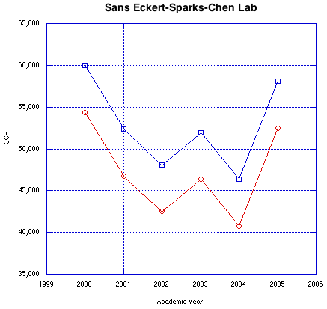
Figure 4.10: The red line is the total water use since 2001 with the Eckert, Sparks, Chen lab water removed. The blue line is the total water used by the campus for reference. It should be noted that the use by the Eckert, Sparks, Chen lab is of the same order as the peak due to the construction of Sontag dorm.

Dining Hall Use

The dining hall usage should be primarily from dishwashing and cooking. We expect that the water used for cooking is probably dwarfed by the dishwasher use, so Table 4-3 shows our estimates for yearly use at Hoch-Shanahan. We estimate that Hoch-Shanahan uses under 3% of the total campus usage including water used for cooking.
Table 4-3 Estimates of Dining Hall Usage
Gal/hour | Hours of Use | School Year | Summer | Total
300 | 7am-9pm | 30 weeks | 6 weeks | 1415 CCF/yr

Residential Use
Dorm water usage is a potentially highly variable amount depending on the building based on the plumbing. For example East (Marks) was built in the 1960s and Sontag is LEED Certified and was built in 2003. Since there is not much separation in the metering data for the dorms, we were forced to use the Atwood meter, which you will recall was relatively isolated on its meter, to predict student usage. We couldn’t use the Case meter as it includes a large portion of landscaping and the cooling tower that serves Case and Linde. The assumption here is that the landscape usage off the Atwood line is minimal. We feel that this is an acceptable assumption because the usage by Atwood was actually higher in the years that the landscaping north of it was not in place due to construction. Also, it currently only provides water to a small number of concrete planters as can be seen in Figure 4.8.
Given that Atwood has on average 132 residents, in 2005-06 they used 2268 CCF for the 36 weeks of occupancy, which is 17.2 CCF per person. Realizing that there are plumbing differences and that this includes some landscaping, we assume 700 students which means that dorm usage is around 12000 CCF or 20.7% of total campus usage. What is interesting about this result is that students have the opportunity to seriously impact HMC’s total usage with conservation efforts! To this end we have created a dormitory water survey that is currently being conducted. See Appendix B for a copy of the survey. The survey is designed to be distributed with one of our water audit kits. A water audit kit consists of a stopwatch as well as a large graduated bucket and a smaller graduated container for measuring shower and faucet flow rates respectively. We also include a pressure gauge and adapter to a faucet so that students can check the static pressure in their pipes. While this does not tell us much about the water usage, it is an important check on the health and status of the plumbing in the buildings. Indoor plumbing should have a static pressure of around 50-60 psi. Too low of a pressure results in an unpleasant use experience, but too high of a pressure can cause damage to the pipes over time especially at corners and junctions in the pipes. A pair of pliers is included with the kit to make sure that students don’t hurt their hands removing the pressure gauge from the faucet. Finally, we ask students to report their toilet rating if it is printed on the unit and to report any leaks or other problems they have in their bathrooms. We also prepared a form that to be posted near a shower that asks students to record the date, time, and duration of their showers (See Appendix C). Our hope was to determine a reasonable average for student shower time. Since we think that is will account for the majority of residential usage, combining this number with the flow rates we obtain from the audit should allow us to make better estimates of residential water usage.
Figure 4.11 shows preliminary results that we have gotten so far from the use of these kits. Two campus groups, Engineers for a Sustainable World (ESW) and Mudders Organizing for Sustainable Solutions (MOSS) were very helpful in gathering the data.
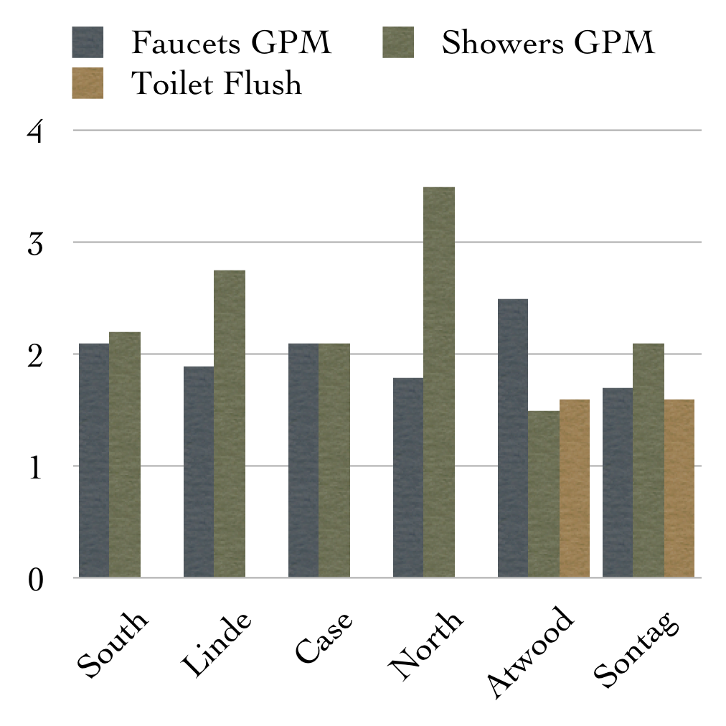
Figure 4.11: Preliminary results from water audit kits. Not every dorm is represented and only a few points have been collected from each dorm.

As expected the older dorms have higher flow rate showers and no reported ratings on the toilets. This data is preliminary since very few data points have thus far been collected for each of the dorms, and not all dorms are represented yet. Sontag, which is a LEED certified dorm, has low-flow toilets as well as reasonably low flow rates from both faucets and showers. Atwood, another of the newer dorms also has low-flow toilets and fairly low flow rates for showers and faucets.

Landscaping Use Revisited
Now that we have estimates for dining, residential, and academic uses, how much is left to go to landscaping? Based on the previous arguments roughly 65% of our total water usage is going towards keeping the campus green. This agrees with our expectation of over 50%, but still leaves room for conservation in other areas to be effective.

Final Estimated Breakdown

The final breakdown of current campus usage as we have estimated above can be seen in Figure 4.12. We have also shown what the campus breakdown should look like after the Eckert, Sparks, Chen lab usage disappears.
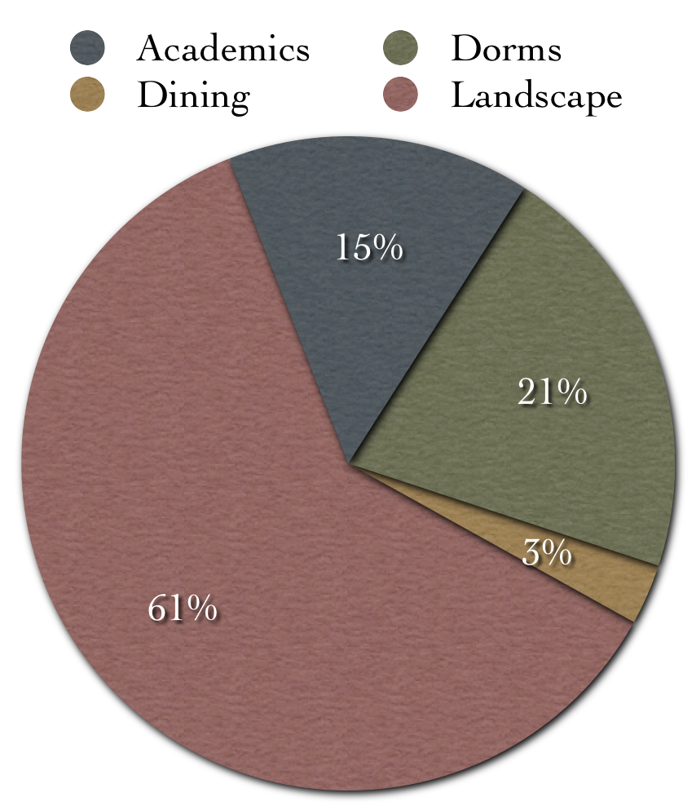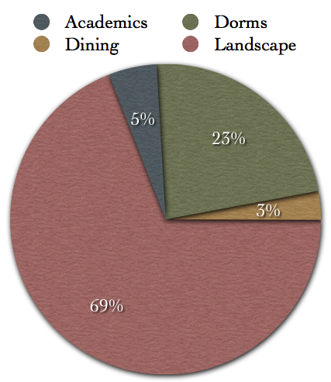
Figure 4.12 Left: Current total campus breakdown. Right: Total campus breakdown sans Eckert, Sparks, Chen lab

On-Going Results and Future Work

Daily Per Person Usage
Using data from the most recent complete school year, HMC uses 119 Gal/day per person (1000 people includes students/faculty/staff), which is just less than the L.A. average of 122 Gal/day []. We also use less than Pomona which averages 139 Gal/day [Error: Reference source not found]. However, we are well above the national average of 100 Gal/day and the German/French usage of 55-60 Gal/day [Error: Reference source not found]. It is likely that the difference between Harvey Mudd’s water usage and the national average as well as the Germans and French has more to do with irrigation water than anything else. The majority of the rest of the nation as well as Germany and France get significantly more rainfall than we do here, so their water cost of irrigation is going to less then ours (Figure 5.13). It is also likely that the difference between Harvey Mudd and Pomona can be attributed to the larger landscaped area at Pomona. According to our estimates, dorm and dining use per student (excluding irrigation and academic use) averages 57 Gal/day. This is inline with the usage per person in a lower irrigation environment like Germany or France, which serves as a validation for our estimates.
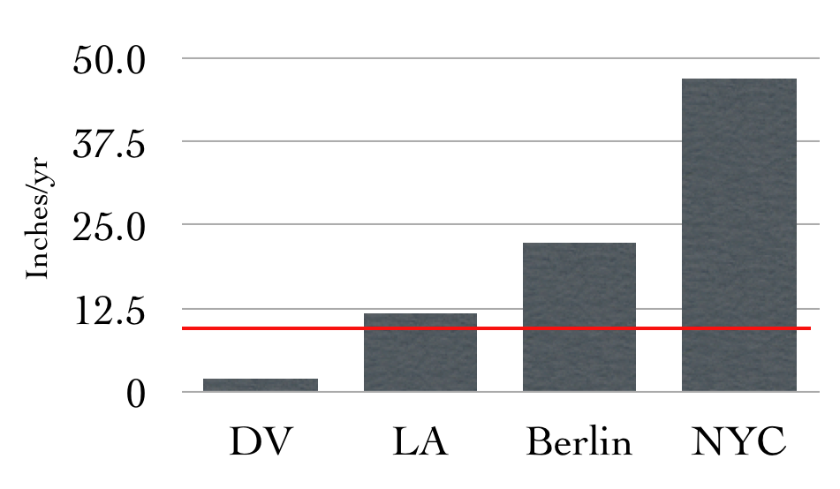
Figure 5.13: Average yearly precipitation in Los Angeles, Death Valley, Berlin, and New York City. The red line indicates the official desert line of 250mm.

While the difference between HMC and the rest of the nation can probably be attributed to the relative levels of precipitation, the proximity of HMC’s daily per person usage to the L.A. average is somewhat disheartening. We would hope that as an institution we would be able to reduce our per person water usage significantly below the amount used in the typical suburban sprawl. Along these lines, while we are not significantly below the L.A. average, we are significantly below the Claremont average of 343 Gal/day per person [Error: Reference source not found]. It should also be noted that Pete Gleick at the Pacific Institute estimated that the bare minimum water needed for an acceptable quality of life in developing countries was 13.2 Gal/day per person [Error: Reference source not found]. This of course did not include irrigation, but did include basic sanitation, cooking, and drinking water. This number is provided here only to put water use in perspective as our ability to turn on the water and have clean potable water is often taken for granted.

Recommendations to Refine Resolution of End Uses
As part of our efforts this semester we came up with a list of places where additional meters would be most helpful for refining water usage data on campus. We ended up suggesting separate meters for the dining hall and for the academic cooling towers. These internal meters could be read monthly by either students or by F&M. It looks like funding is coming through for these meters and that they will be installed sometime in 2007 assuming all goes well. These meters will allow for a much better breakdown of usage on campus. Should additional meters be approved, we recommend that singling out individual dorms would be the best next step.
The ideal situation would have been to put individual meters on each building. This, however, was not economically feasible due to the cost of metering. Meters are surprisingly expensive, on the order of $3,000 - $5,000 for the size meters we would want to place on a building. That does not include installation costs. Given that we only spend about $120,000 a year on water, spending $3,000 - $5,000 per building to monitor water use across campus does not make economic sense. So, we realized that we would have to choose a small number of strategic locations that would best help refine the resolution of end uses on Harvey Mudd’s campus. Our choice of location was further restricted by pipe size and location. As a rule of thumb, the larger the pipe is, the more expensive the meter will be. Furthermore, if the pipe is located underground, like the N. Mills Line, there are increased installation costs for the excavation to get to it. If an underground pipe is run along with other utilities like electricity or gas, then the cost and risk of installation goes up even more since the water line would have to be cut while in amongst those other service lines. Given these limitations, we arrived at our decision to request meters for the dining hall and the academic cooling towers, both of which are above ground installations on relatively small pipes.
Even though we suspect dining is a small percentage of the total campus usage, it is the only case in which one building accounts for an entire end use. We also have no good way to estimate the amount of water needed for cooking, so there is a good chance that our estimate could be inaccurate if our assumption of negligible cooking water turns out to be false. The second meter that we recommended on the academic cooling towers was put in place because these are the largest cooling towers on campus. We think that they might account for a large percentage of academic use (after the Eckert, Sparks, Chen lab) and so being able to quantify that amount would go a long way to quantify academic use. We also chose them because they are the cooling towers responsible for the largest square footage on campus. If we then assume similar performance between these cooling towers and the other evaporative cooling towers on HMC, we can use data from that meter to estimate the use of other cooling towers (i.e. Kingston and Case/Linde) based on the square footage they serve. Tom Shaffer has suggested that for some of the cooling towers, the assumption of similar performance may not be a good one, but this meter is the best step we can take at the moment to get a handle on cooling tower use.

New Information Resources
In the course of our research this semester we found out about the Association for the Advancement of Higher Education (AASHE). Thanks to the Office of the Dean of Faculty we were able to become a member institution. This is particularly exciting as it is a great online resource open to every student and faculty member of HMC. AASHE offers a database of reports compiled by other higher education institutions on sustainability efforts on their campus and provides a basis for collaborative efforts in sustainability. It is our hope that the work done by this project, as well as that by the various campus groups, can be added to AASHE’s repository.
Anyone can access the AASHE materials with just their Harvey Mudd email address. The website is www.aashe.org.

What about those Flush-Less Urinals?
The plaques above the flush-less urinals tell us that each urinal saves 40,000 Gal a year. Our estimates for bathroom usage on the academic end suggest that the urinals in fact save less than 1% of our total water usage each year. While we do not want to suggest that saving water is a bad thing, it is likely that the cost of the replacement cartridges for the urinals make the economic savings in this case minimal or nonexistent.
Saving water for the sake of saving water address two of the three costs, social and environmental, but it fails to address the third, economic, which is often the motivation for such measures. While gestures like the flush-less urinals certainly make an impression and can go a long way to putting HMC in a position of leadership with regard to water conservation, such actions that do not have clear economic benefit should be embarked upon carefully so as not to jade the institution against future endeavors.

Preliminary Look at the Feasibility of a Cistern System
There is no doubt that installing a cistern system would be expensive, at least on the order of hundreds of thousands. However, if HMC ever gets to a point where the conservation of water becomes more important than the economic cost of water, or the economic cost of water rises to the point where it becomes a more costly resource, installing a cistern system could become a viable option.
The major contributors to a cistern system would be rainfall on campus, runoff from landscaping, and possibly grey water from showers and faucets. Since our landscaping system is designed to water according to what the plants and soil need given the current weather, runoff should be limited and a quick look at rainfall can give us an idea of whether or not such a system could become feasible.
In Claremont we get about 14 inches of rain a year. HMC’s campus is about 34 acres. That means that over 34 acre-feet fall on HMC’s campus a year. That is about 15,000 CCF a year, which is about a quarter of our total usage currently. Assuming that we are able to collect 50% of the rainwater that falls on HMC, it would account for 20% of the landscaping usage on HMC. Since the water would be untreated, its only real use would be landscaping. Those are conservative estimates, and we would likely be able to design a system that is more efficient than this. If we also collected sprinkler run off from the sidewalks and some grey water from the dishwashers, showers, and faucets we could likely dramatically increase this amount. While it is true that the water from these sources would probably need some filtering, it would likely not be prohibitive. Even with reclaiming 20% of the landscaping usage, at current prices that amounts to about $15,000 a year in savings. Which means that there would be a finite payback time for the system.

Future Work Recommendations
Future work on water should focus on campus awareness and conservation efforts. It is clear from our breakdown that students have the ability to directly affect the bottom line of the water usage on campus. Additionally, public support for Mike Barber and his team would also be generated simply by publicizing their landscaping efforts, as they have done a tremendous job of replacing water-hungry ground cover with California native plants and low-flow drip systems. Also, we found that the current master landscape plan is mostly immutable by F&M. However, a strong outcry from the students could easily allow for drawing up a new plan that replaces even more of the water-thirsty vegetation with California natives, though careful consideration should me made of the value of lawn areas before they are removed.
Direct continuation of the work would include gathering more data from the water audit kits to paint a better picture of dorm usage. We can get a reasonable number from Atwood, but it would be better if this were adjusted across the other dorms based on relative shower flow rates (since showers probably account for the majority of dorm usage). It would also be good to check the approximation using Atwood against estimates derived from water audit data. Additionally, a different audit of the various academic labs would allow for a better approximation of their water use as well as better identify where the major water users are. Hopefully, the meters we recommended will be installed at the beginning of the coming summer, so that that data will become available to students continuing to look at water in the future.
All the data collected in the process of this project has been submitted to Professors Haskell and Lynn so that it should be available to future students who wish to pick up where we left off.

Acknowledgements
This study was only possible through the cooperation of numerous people and groups. We’d like to thank Tom Shaffer and Mike Barber for the virtually endless meetings and help provided as well as Jon Roberts HM ‘93, Andrew Dorantes, Theresa Potter, Femke Oldham PO ‘07, Jeff Groves, Holly Hauck, Danny Goroff, Paul Steinberg, Maria Klawe, The Center for Environmental Studies, MOSS, and ESW.

Appendix A: California Native Plants Used on Harvey Mudd Campus

1. Arctostaphylos 'john dourley'
2. Arctostaphylos denisflora ' Howard'
3. Arctostaphylos edmundsii
4. Ceanothus 'Concha'
5. Ceanothus 'Ray Hartman'
6. Erigeron Glaucus 'Wayne Roderick'
7. Heteromeles arbutifolia
8. Heuchera Maxima
9. Iris Douglasiana
10. Mahonia aquifolium
11. Mahonia repens
12. Mimulus alaongiflorus
13. Rhamnus Californica 'Eve case'
14. Rhus Ovata
15. Ribes Sanguineum glutinosum
16. Salvia chamaedryoides
17. Salvia clevelandii
18. Zauschneria californica
19. Arbutus Unedo 'compacta'
20. Carpenteria californica
21. Ceanothus G. Var ahaorizontalis
22. Cercis Occidentalis
23. Echium fastuosum
24. Fremontodendron 'california glory'
25. Heuchera Sanguinea 'Suzanna'
26. Mahonia Repens
27. Prunus Ilicifolia
28. Rhaphiolepis 'Ballerina'
29. Romney coulteri
30. trachelospermum jasminoides
31. trichostema Lanatum
32. Yucca Whipplei

Appendix B: Water Audit Form

Dorm: __________ Room/Suite Number (or Case L): _________ Date: ________
Water Audit Form for Dorm Facilities
April 4, 2007
Version 1.0

This water audit is being conducted as part of a larger look at water usage on Harvey Mudd College campus. For questions or more information, please contact Whitney Buchanan at wbuchanan@hmc.edu.

Faucet Flow Rate:
Use the smaller 10 cup container and the stopwatch. Time the flow for approximately 10-15 seconds and measure the volume of water from the faucet for that time period. Record time and volume below:

Time: _______ seconds Volume: _______ cups

Shower Flow Rate:
Using the large graduated bucket and stopwatch, time the flow for approximately 30 seconds and measure the volume of water from the shower for that time period. Record time and volume below:
Time: _______ seconds Volume: _______ cups

Static Pressure:
Unscrew the aerator from one of the sink faucets. Run your finger around the inside of your faucet to remove any gunk that might be in there as it may damage the pressure gauge if it gets in there. Screw in the pressure gauge and using the adapter provided. Get it as tight as you can, and then turn on the water. Read off the pressure. Record it below:

Pressure: _______ psi

Note: We have provided pliers to help you remove the pressure gauge as it can be difficult to remove. Please be careful not to cut your fingers on the threads.

Toilet rating:
If the toilet has a flow rating printed on it (usually located behind the seat), please record it below. If not, cirlce “no rating”:
Rating: ______gal/flush No rating

Observations:
Please list any other observations you have about your bathroom/kitchen facilties (i.e. any leaks, pressure variations etc.) Use the back of this sheet.
Auditor Contact Info:
Name:__________________________ Email:______________________

Appendix C: Shower Time Audit Form

Dorm: __________ Room/Suite Number (or Case L): _________ Date: ________
Shower Usage Tally
This data is being collected as part of a larger look at water usage on Harvey Mudd College campus. For questions or more information, please contact Whitney Buchanan at wbuchanan@hmc.edu.

Please list the date, time, and approximate duration of your shower.

Date Time Duration
______________ _________________ __________________
______________ _________________ __________________
______________ _________________ __________________
______________ _________________ __________________
______________ _________________ __________________
______________ _________________ __________________
______________ _________________ __________________
______________ _________________ __________________
______________ _________________ __________________
______________ _________________ __________________
______________ _________________ __________________
______________ _________________ __________________
______________ _________________ __________________
______________ _________________ __________________
______________ _________________ __________________
When full, please return to Whitney Buchanan’s mailbox, or contact wbuchanan@hmc.edu for pick up.

References

An idea originally presented to us by Professor Jeff Groves.
[?] “California’s Groundwater: Bulliten118.” State of California Department of Water Resources. Chapter 1. Access Date: 2 May 2007. <http://www.dpla2.water.ca.gov/publications/groundwater/bulletin118/Bulletin118-Chapter1.pdf>
[?] “Weather and Climate: Death Valley National Park” National Park Service. Access Date: 2 May 2007. <http://www.nps.gov/deva/planyourvisit/upload/Weather%20and%20Climate.pdf>
[?] “State Water Project-Geography” State of California Department of Water Resources. Access Date: 2 May 2007. <http://www.publicaffairs.water.ca.gov/swp/geography.cfm>
[?] “Golden State Water Company: Communities Served.” American States Water Company. Access Date: 2 May 2007. <http://www.aswater.com/Organization/Company_Links/Regions/Region_3/region_3.html>
[?] Oldham, Femke. “Water at Pomona College: An Investigation of Policies and Practices.” Senior Thesis. Chapter 2. (2007).
[?] “Water Issues in the City of Claremont 2005.” The League of Women Voters of the Claremont Area. 2005. Access Date: 2 May 2007 <http://www.claremont.ca.lwvnet.org/files/report_with_graphs_mar_23_2006.pdf>
[?] Access Date: 2 May 2007 <http://www.mulholland-drive.net/pics/studies/william_mulholland.jpg>
[?] Reisner, Marc. Cadillac Desert. New York: Penguin Books, 1987. Pgs. 52-103.
[?] Santa Clarita Valley Historical Society: St. Francis Dam. Access Date: 2 May 2007. <http://www.scvhistory.com/scvhistory/hs2809.htm> <http://www.scvhistory.com/scvhistory/sp2822.htm>
[?] “Notice of Reopening of Comment Period on Draft Recovery Plan for the Wetland and Aquatic Species of the Owens Basin, Inyo and Mono Counties, California and Related Public Information Workshops.” Environmental Protection Agency. Access Date: 2 May 2007. <http://www.epa.gov/fedrgstr/EPA-SPECIES/1997/January/Day-13/pr-10318.html>
[?] Walker, Courtney. “Water Returns to Owens River, Reclaiming “the Switzerland of California” from the Desert.” California Progress Report. Access Date: 2 May 2007. <http://www.californiaprogressreport.com/2006/12/water_returns_t.html>
[?] Reisner, Marc. Cadillac Desert. New York: Penguin Books, 1987. Pgs. 120-144, 255-305.
[?] “State Water Project-Overview” State of California Department of Water Resources. Access Date: 2 May 2007. <http://www.publicaffairs.water.ca.gov/swp/>
[?] “Bulletin 132: Management of the State Water Project.” State of California Department of Water Resources. Access Date: 2 May 2007. <http://www.swpao.water.ca.gov/publications/index.cfm>
[?] Access Date: 2 May 2007. <http://www.publicaffairs.water.ca.gov/swp/pdf/SWPmap.pdf>
[?] “U.S. Supreme Court. Cappaert v. United States, 426 U.S. 128 (1976). Access Date: 2 May 2007. <http://caselaw.lp.findlaw.com/scripts/getcase.pl?court=us&vol=426&invol=128&friend=nytimes>
[?] Rothfeder, Jeffrey. Every Drop For Sale. New York: Penguin Books, 2004. Pgs. 57-65.
[?] “Refining Estimates of Water-Related Energy Use in California” California Energy Commission. Access Date: 2 May 2007. <http://www.energy.ca.gov/pier/final_project_reports/CEC-500-2006-118.html>
[?] Golden State Water Company: Schedule No. R3-1
[?] City of Claremont Municipal Code. Access Date: 2 May 2007. <http://www.ci.claremont.ca.us/municipalcode.cfm>
[?] “Estimating Freshwater Needs to Meet 2025 Electricity Generating Capacity Forecasts.” Department of the Interior. Access Date: 3 May 2007 <http://www.doi.gov/water2025>
[?] Alexander, Greg, Chris Hanusa, Ryan Kirby, Marci La Violette, Jill Sohm, and Tracy van Cort. “Regional Landscape Clinic: Final Report.” Access Date: 3 May 2007. <http://www4.hmc.edu:8001/EnvStudies/Landscape/>
[?] Jim Eckert. Interview with Whitney Buchanan. April 24, 2007.
[?] Champion 64 KPRB 86” Specifications. Received from Tom Shaffer.
[?] Per Bill Casey, General Manager, HMC Dining Services
[?] National Wildlife Foundation. Access Date: 3 May 2007. <http://www.nwf.org>

