### HMC_Seal

### HMC Machine Shop Safety Manual

2012

## Table of Contents

INTRODUCTION [Page 3](#Page_3)

GENERAL SHOP SAFETY [Page 4](#Page_4)

Safety Rules [Page 5](#Page_5)

PPE- Personal Protective Equipment [Page 6](#Page_6)

Housekeeping [Page 8](#Page_8)

Hazardous Materials [Page 9](#Page_9)

SPECIFIC MACHINE SAFETY PRACTICES [Page 10](#Page_10)

Mills [Page 10](#Page_10b)

Drill Press [Page 11](#Page_11)

Table Saw [Page 12](#Page_12)

Band Saw [Page 13](#Page_13)

Metal Lathe [Page 14](#Page_14)

Wood Lathe [Page 17](#Page_17)

Pedestal Grinder [Page 19](#Page_19a)

Belt Sander [Page 19](#Page_19b)

Metal Forming Tools [Page 20](#Page_20)

Heat Treatment [Page 21](#Page_21)

Welding [Page 22](#Page_22)

Jointer [Page 23](#Page_23)

SHOP USER AGREEMENT [Page 24](#Page_24)

|  |
| --- |
| INTRODUCTION |

The purpose of the HMC Machine Shop Safety Manual is to provide shop users with information on how to protect themselves from shop and machine hazards and to comply with HMC safety guidelines and applicable Cal OSHA regulations for machine safeguarding.

**Machine shop responsibilities**:

The HMC Machine Shop Manager and Safety Coordinator are responsible for assisting users with safety information and training.

The HMC Machine Shop Manager is responsible for

* the overall supervision and management of the HMC machine shops
* ensuring machine safeguards are properly installed and operating
* safety training and re-training of shop users
* providing users with the proper personal protective equipment

The HMC Safety Coordinator works closely with the Claremont University Consortium Office of Environmental Health and Safety to provide safety services to the HMC machine shops. The HMC Safety Coordinator is responsible for

* monitoring the overall effectiveness of the shop safety program
* maintaining training records
* coordinating an annual inspection of all shop areas
* providing or acquiring technical assistance as needed.

All shop users are responsible for

* completing the shop safety training requirements
* following shop safety guidelines
* making sure that you have checked in with a shop proctor.
* reporting all shop related accidents.

**Machine Shop Access**

To use the HMC machine shops, users must complete the safety trainings. Initial safety training includes attending the machine shop safety orientation class, a tour of the machine shops with the shop manager or shop proctor, signing the HMC Machine Shop User Agreement, and passing the machine shop safety test. Each year all returning shop users must complete and pass the machine shop safety test.

**Hours of operation**

Regular shop hours are Monday through Friday 9am to 11pm, excluding school holidays. Some students will have restricted use of the machine shops based on class and/or instructor guidelines. There must always be a shop proctor on duty for any student to use the shops.

**Reporting Accidents**

Accidents can and DO happen. Know the location of the first aid cabinet and obtain medical or emergency treatment as needed. Accidents occurring in the shop are to be immediately reported to the HMC Machine Shop manager, student shop proctor, dorm proctor on-call or Campus Safety. Always report injuries no matter how minor. A minor injury could later develop into a serious or emergency situation. Emergency numbers are posted on shop bulletin boards.

**HMC Machine Shop Contact Information**

**Machine Shop Manager**

Paul Stovall

Galileo B5

(909) 607-3050

**E4 Shop Coordinator**

Liz Orwin

Parsons 2367

(909) 621-8572

**HMC Safety Coordinator**

Melonee Cruse

Platt Campus Center basement

(909) 607-0403

**Campus Safety**

251 E. Eleventh Street

(909) 607-20000

**CUC Environmental Safety and Health Office**

Jay Brakensiek

(909)621-8538

|  |
| --- |
| General Shop Safety Machine Shop Requirements for Shop Safety |

This handout is designed to acquaint new and experienced shop users with some common shop hazards. Its goal is to prevent injuries to the people who use this equipment. As you read the material, you should realize that a major part of shop safety is based upon common sense and thinking ahead. It is an accepted fact that forethought and the elimination of carelessness can avoid virtually all shop accidents.

Before you make a move, think about what might occur. THINK AHEAD. Develop the habit of never trusting mechanical devices. Never place yourself in a position where you could be hurt if something mechanical failed. Your hands are especially vulnerable. Always be on the watch for possible pinch points that could develop. Give your undivided attention and thought to the task before you. Daydreaming or talking with a friend reduces your attention on the job.

Maintaining shop safety is a full-time job. You can never relax in your accident prevention habits. Remember that safety is a habit, and it must be practiced until it is automatic. If you ever encounter a situation you're not sure of with regard to safety, consult with the shop manager, a shop proctor or an instructor.

|  |
| --- |
| General Shop Safety - Safety Rules |

***-THINK AHEAD.  
-USE COMMON SENSE.  
-DON'T TRUST MACHINES.  
-PAY ATTENTION TO WHAT YOU'RE DOING. FOCUS ON THE TASK AT HAND.***

***General Shop Safety Precautions***

1. Know and comply with safety rules and regulations governing required protection and conduct in the areas in which you work.
2. Before starting a machine, always check it for correct setup and if possible, check to see if machine is clear by operating it manually.
3. Do not distract a person operating a machine
4. Ask the shop proctor or machine shop manager questions to remove any doubt about the safe way to perform any job.
5. Do not make alterations or perform major repairs on any safety equipment unless specifically authorized.
6. All machines must be operated with all required guards and shields in place. Do not interfere with any method or process adopted for the protection of a shop user.
7. Operate only those machines and equipment you have been specifically trained to use or qualified to use.
8. Take every precaution so that tools and materials are not, by reason of location or use, a hazard to others.
9. Use the proper tool for the job. Many injuries in the shop occur because a wrench slips and a hand hits a sharp cutting tool.
10. Keep your fingers clear of the point of operation of machines by using special tools or devices, such as, push sticks, hooks, pliers, etc. **Never use a rag or gloves near moving machinery.**
11. Check tools before use to assure they are safe to use. Check the power cords and plugs on portable tools for damage before using them.
12. Do not leave tools or work on the table of a machine even if the machine is not running. Tools or work may fall off and cause a toe or foot injury.
13. Machines **must be shut off** when cleaning, repairing, or oiling.
14. A brush, hook, or special tool is preferred for removal of chips, shavings, etc. from the work area. **Never** use your hands to clean cuttings – they are sharp.
15. Never wear gloves or use rags to clean the work piece or any part of a machine that is running. Rotating tools or parts can grab gloves and rags and pull you into the machine.
16. Do not use compressed air to blow dirt or chips from machinery to avoid scattering chips. Never use compressed air guns to clean clothing, hair, or aim the gun at another person.
17. If using compressed air to clean a part, point the air hose down and away from yourself and other persons.
18. Never indulge in horseplay in the shop areas.
19. Do not block aisles, passageways, corridors, fire lanes, or fire and emergency equipment.
20. Get first aid immediately for any injury. Call Campus Safety (ext 72000) for immediate assistance.
21. Do not attempt to remove foreign objects from the eye or body. Report to the student health service for medical treatment. If chemicals get in the eye(s), wash eye(s) for 15 minutes in an open flow of water before proceeding for medical treatment.
22. Every accident must be immediately reported to a shop proctor, the HMC shop manager, dorm proctor on-call and Campus Safety. A near miss or minor incident should also be reported. Actions taken to correct any minor problems can help avoid future mishaps.
23. Get help for handling large, long, or heavy pieces of material or machine attachments.
24. Follow safe lifting practices; lift with your leg muscles, not your back. If you do not know how to lift safely, ask an instructor to show you.
25. A hard hammer should not be used to strike a hardened tool, another harden hammer, or any machine part. Use a soft-faced/lead hammer only.
26. Be sure you have sufficient light to see clearly. Check with an instructor or HMC Shop Manager if you do not have enough.
27. **Always consult shop personal before cutting or grinding any small work pieces.**
28. **SAFETY NOTE!** NEVER attempt to operate a machine while your senses are impaired by medication or other substances.
29. Always wait for hand held power tools to come to a complete stop before laying them down.

|  |
| --- |
| General Shop Safety- PPE Clothing and Safety Equipment for the Machine Shop |

**Hearing Protection**

**Hearing Safety**

Many manufacturing processes are very noisy and can result in permanent deafness if suitable precautions are not taken. For example, hand grinders produce very high noise levels. Also, people using a pneumatic chisel or power saw are likely to be exposed to noise levels that can seriously damage their hearing.

REMEMBER: The danger is irreversible - a hearing aid will not replace lost hearing.

HMC supplies ear plugs for the students and are free of charge. These fit inside the ear canal and can be reusable or disposable according to the manufacturer's instructions. They may sometimes be attached to a cord to prevent being lost. Ear plugs may not be suitable for people with a history of ear problems (Figure 1).

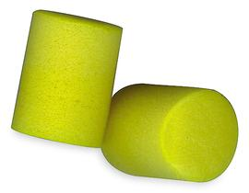Fig. 1

Figure 1 Disposable ear plugs are made of soft, noise-absorbing foam.

**Selection**

There are three main things to consider when selecting hearing protectors:

1. Will they give sufficient protection? The frequency, content, and volume of the noise must be considered. For construction plant noise, data should be obtained from the manufacturer or supplier. The data, plus any site measurement data obtained by employers, should be used along with performance data supplied by manufacturers. The information should be used to ensure that the equipment is suitable.
2. Are they right for the working conditions? If processes are dusty or dirty, soft plugs, which need to be molded by hand, could lead to ear infections unless good personal hygiene is observed.
3. Are they right for the wearer? Long hair, thick spectacle frames may prevent the muffs from forming a close seal to the head  or reducing the muffs' effectiveness

**Using Hearing Protectors**

Hearing protectors will only give proper protection if they fit, are worn properly, and are used whenever the wearer is exposed to high noise levels. The more comfortable they are, the more likely it is that workers will use them properly. Taking them off even for a short time when noise levels are high can quickly allow hearing damage to occur.

REMEMBER: Hearing protectors that doesn’t fit, doesn’t protect!

**EYE PROTECTION**

Many machining processes present a risk of injury to the eyes and face. For example, protection will be needed against flying chips or particles when using a disc cutter or cartridge - operated tools against arc eye and molten metal splash when using welding equipment or hot cutting metal, and against corrosive or irritant chemical splashes when working with epoxy resins and concrete.

REMEMBER:  Personal protective equipment (PPE) is always the last line of defense; wherever possible use face shields and machine guards.

**Types of Eye Protection**

There are two types of eye and face protectors available, spectacles and goggles. (Figure 3.)

|  |  |  |
| --- | --- | --- |
| http://its.fvtc.edu/MachShop1/ShopSafe/glasses.jpg |  | http://its.fvtc.edu/MachShop1/ShopSafe/goggle.jpg |
| Figure 3. Safety glasses and goggles provide important eye and face safety and should be used whenever the type of job requires eye or face protection. | | |

**General PPE Safety Practices**

1. ALWAYS wear SAFETY GLASSES or safety goggles designed for the type of work being done when operating any machine or doing any work in the shop.
2. **Wear your safety glasses or safety goggles at all times you are in the shop.**
3. Wear shirts with short sleeves, sleeves cut off or rolled up above the elbows.
4. Wear closed-toed shoes and if required, wear thick penetration resistant leather soles-safety shoes or boots.
5. Always remove gloves before turning on or operating any machine. If material is rough or sharp and gloves must be worn, place or handle material with the machine turned **Off**.
6. Do not wear ties, loose clothing, jewelry, gloves, etc. around moving or rotating machinery. Long hair must be tied back or covered to keep it away from moving machinery. Hand protection in the form of suitable gloves should be used for handling hot objects, glass or sharp-edged items. Do **NOT** wear gloves while operating machinery
7. Wear appropriate clothing for the job (i.e. do not wear short sleeve shirts or short pants when welding). **DO NOT WEAR**:
   * Tennis shoes (wear thick soled leather shoes, which provide some protection for the feet)
   * Sandals
   * Shorts, cutoffs, Bermuda or short-shorts
   * Tank tops, muscle shirts, etc.
   * Neckties, loose or torn clothing
   * Rings, watches, bracelets, or other jewelry that could get caught in moving
   * machinery
   * Loose clothing or long sleeves (machines can easily grab loose clothing in rotating parts)

|  |
| --- |
| General Shop Safety - Housekeeping |

1. Aisles should be clear at all times to avoid tripping or other accidents.
2. Keep floors free of oil, grease, or any other type of liquid. Clean up spilled liquids immediately; they are slipping hazards.
3. Keep the floor clear of metal swarfs and scrap pieces. Put them in the containers provided for them. Scrap pieces are tripping hazards, and metal swarfs may cut through a shoe and injure the foot.
4. Keep the floor around machines clean, dry and free from trip hazards. Do not allow wood chips or sawdust to accumulate.
5. Place all scrap pieces in the correct containers.
6. Store materials in such a way that they cannot become tripping hazards.
7. Put tools away when not in use.
8. Clean your work area after use, brush tables and place waste in proper containers.



[Machine Tool Courses](http://its.fvtc.edu/machine/login.htm" \t "_top)



[Contact Us](http://its.fvtc.edu/MachShop1/contact.htm" \t "_top)  
[Computer Requirements](http://its.fvtc.edu/MachShop1/require.htm" \t "_top)



**[Introduction Content](http://its.fvtc.edu/MachShop1/intro/intro.htm" \t "_top)**



**[Contact Instructor](http://its.fvtc.edu/MachShop1/contact.htm" \t "_top)**  
**[Computer Requirements](http://its.fvtc.edu/MachShop1/require.htm" \t "_top)**  
**[MS1 Scoring Sheet](http://its.fvtc.edu/MachShop1/Scoresht.htm" \t "_top)**



**[Main Page](http://its.fvtc.edu/MachShop1/ShopSafe/default.htm" \t "_top)**



**[Shop Requirements](http://its.fvtc.edu/MachShop1/ShopSafe/Requirements.htm" \t "_top)**  
**[Safety Rules](http://its.fvtc.edu/MachShop1/ShopSafe/rules.htm" \t "_top)**  
**[Clothing & Equipment](http://its.fvtc.edu/MachShop1/ShopSafe/Cothing.htm" \t "_top)**  
**[Housekeeping](http://its.fvtc.edu/MachShop1/ShopSafe/housekeep.htm" \t "_top)**  
**[General Safety (eye/ear)](http://its.fvtc.edu/MachShop1/ShopSafe/general.htm" \t "_top)**  
**[Hazardous Materials](http://its.fvtc.edu/MachShop1/ShopSafe/hazmat.htm" \t "_top)**  
**[Lockout/Tagout](http://its.fvtc.edu/MachShop1/ShopSafe/Lockout.htm" \t "_top)**  
**[Rigging & Lifting](http://its.fvtc.edu/MachShop1/ShopSafe/rig_lift.htm" \t "_top)**  
**[Machine Safety](http://its.fvtc.edu/MachShop1/ShopSafe/machine.htm" \t "_top)**



**[REVIEW - Shop Safety](http://its.fvtc.edu/MachShop1/ShopSafe/shopsafty/index.html" \t "_top)**



**[Main Page](http://its.fvtc.edu/MachShop1/layout/default.htm" \t "_top)**



**[Content - Layout](http://its.fvtc.edu/MachShop1/layout/LayoutPced.htm" \t "_top)**  
**[REVIEW - Layout](http://its.fvtc.edu/MachShop1/layout/layout/index.htm" \t "_top)**



**[Main Page](http://its.fvtc.edu/MachShop1/Inspection/default.htm" \t "_top)**



**[Inspection Projects](http://its.fvtc.edu/MachShop1/Inspection/project.htm" \t "_top)**



**[Steel Rule Information](http://its.fvtc.edu/MachShop1/Inspection/stlrule.htm" \t "_top)**  
**[Types of Steel Rules](http://its.fvtc.edu/MachShop1/Inspection/types.htm" \t "_top)**  
**[Rule - Common Questions](http://its.fvtc.edu/MachShop1/Inspection/FAQ.htm" \t "_top)**   
**[Angular Measurement](http://its.fvtc.edu/MachShop1/Inspection/Anglemeas.htm" \t "_top)**  
**[Depth Measurement](http://its.fvtc.edu/MachShop1/Inspection/Depthmic.htm" \t "_top)**  
**[Metric Micrometer](http://its.fvtc.edu/MachShop1/Inspection/Metricmic.htm" \t "_top)**  
**[Inside Measurement](http://its.fvtc.edu/MachShop1/Inspection/Insidemeas.htm" \t "_top)**  
**[Indirect Measurement](http://its.fvtc.edu/MachShop1/Inspection/Indirectmeas.htm" \t "_top)**  
**[Micrometer Adjustments](http://its.fvtc.edu/MachShop1/Inspection/Adjustmic.htm" \t "_top)**



**[Review-Fixed Gages](http://its.fvtc.edu/MachShop1/Inspection/gages/index.html" \t "_top)**  
**[Review-Steel Rule](http://its.fvtc.edu/MachShop1/Inspection/steelrule/index.html" \t "_top)**  
**[Review-Angular Measure](http://its.fvtc.edu/MachShop1/Inspection/angmeas/index.html" \t "_top)**  
**[Review-Indirect Measure](http://its.fvtc.edu/MachShop1/Inspection/indirmeas/index.html" \t "_top)**  
**[Review-Vernier ID](http://its.fvtc.edu/MachShop1/Inspection/vernID/vernier/index.html" \t "_top)**  
**[Review-Vernier Measure](http://its.fvtc.edu/MachShop1/Inspection/verniermsure/index.html" \t "_top)**  
**[Review-Micrometer Parts](http://its.fvtc.edu/MachShop1/Inspection/micrometer1/index.html" \t "_top)**  
**[Review-Micrometer Meas.](http://its.fvtc.edu/MachShop1/Inspection/Micromeasr/index.html" \t "_top)**  
**[Review-Metric Micrometer](http://its.fvtc.edu/MachShop1/Inspection/micrometric/index.html" \t "_top)**  
**[Review-Depth Micrometer](http://its.fvtc.edu/MachShop1/Inspection/t_micro/index.html" \t "_top)**  
**[Review-Dial Caliper ID](http://its.fvtc.edu/MachShop1/Inspection/dcalipid/index.html" \t "_top)**  
**[Review-Dial Caliper Meas.](http://its.fvtc.edu/MachShop1/Inspection/dcalipmeas2/index.html" \t "_top)**



**[Main Page](http://its.fvtc.edu/MachShop1/Bench/default.htm" \t "_top)**



**[Screw Threads & Fasteners](http://its.fvtc.edu/MachShop1/Bench/fasten.htm" \t "_top)**  
**[REVIEW - Files](http://its.fvtc.edu/MachShop1/Bench/files/index.html" \t "_top)**  
**[REVIEW - Pedestal Grinder](http://its.fvtc.edu/MachShop1/Bench/Pedgrind/index.html" \t "_top)**  
**[REVIEW - Hacksaws](http://its.fvtc.edu/MachShop1/Bench/hacksaw/index.html" \t "_top)**  
**[REVIEW - Taps & Dies](http://its.fvtc.edu/MachShop1/Bench/tap_dies/index.html" \t "_top)**  
**[REVIEW - Screw Threads & Fasteners](http://its.fvtc.edu/MachShop1/Bench/screwthrds/index.html" \t "_top)**



**[Main Page](http://its.fvtc.edu/MachShop1/coolant/default.htm" \t "_top)**



**[Cutting Fluids Info Sheet](http://its.fvtc.edu/MachShop1/coolant/cutfluids.htm" \t "_top)**  
**[Project 1](http://its.fvtc.edu/MachShop1/coolant/cutflproj1.htm" \t "_top)**



**[Main Page](http://its.fvtc.edu/MachShop1/Sawing/default.htm" \t "_top)**



**[Project Sheet 1](http://its.fvtc.edu/MachShop1/Sawing/project1.htm" \t "_top)**  
**[Project Sheet 2](http://its.fvtc.edu/MachShop1/Sawing/project2.htm" \t "_top)**  
**[REVIEW-Sawing Machines](http://its.fvtc.edu/MachShop1/sawing/index.html" \t "_top)**



**[Main Page](http://its.fvtc.edu/MachShop1/Drillpress/default.htm" \t "_top)**



**[Content-Feed Rate Calc](http://its.fvtc.edu/MachShop1/Drillpress/Feedratecalc.htm" \t "_top)**  
**[Content-Cut Speeds](http://its.fvtc.edu/MachShop1/Drillpress/cutspeeds.htm" \t "_top)**  
**[Project Sheet 1-1](http://its.fvtc.edu/MachShop1/Drillpress/project1.htm" \t "_top)**  
**[Project Sheet 1-4](http://its.fvtc.edu/MachShop1/Drillpress/project4.htm" \t "_top)**  
**[Project Sheet 1-5](http://its.fvtc.edu/MachShop1/Drillpress/project5.htm" \t "_top)**  
**[Project Sheet 1-6](http://its.fvtc.edu/MachShop1/Drillpress/project6.htm" \t "_top)**  
**[Project Sheet 1-7](http://its.fvtc.edu/MachShop1/Drillpress/project7.htm" \t "_top)**  
**[Radial Project Sheets](http://its.fvtc.edu/MachShop1/Drillpress/default.htm" \t "_top)**  
**[REVIEW-Drill Press ID](http://its.fvtc.edu/MachShop1/Drillpress/index.html" \t "_top)**  
**[REVIEW-Adv. Cut Tools](http://its.fvtc.edu/MachShop1/Drillpress/advcuttool/index.html" \t "_top)**  
**[REVIEW-Cutting Speeds](http://its.fvtc.edu/MachShop1/drillpress/drill_rpmcalc1/index.html" \t "_top)**  
**[REVIEW-Radial Drilling](http://its.fvtc.edu/MachShop1/drillpress/radialdrl/index.html" \t "_top)**



**[REVIEW-Drill Accessories](http://its.fvtc.edu/MachShop1/drillpress/index1.html" \t "_top)**



**[Main Page](http://its.fvtc.edu/MachShop1/test.htm" \t "_top)**

|  |
| --- |
| General Shop Safety – Hazardous Materials |

Federal and state law dictates that employers must provide information to their employees about hazardous materials and chemicals that employees may be exposed to in the workplace. The vehicle for that information is the Material Safety Data Sheet (MSDS). A Material Safety Data Sheet (MSDS) is used by chemical manufacturers and importers to convey both the physical hazards (pH, flashpoint, flammability, etc.) and the health hazards (carcinogenicity, teratogenicity, etc.) of their chemicals to the end user. The Cal- OSHA MSDS format has the following required categories that must be on every MSDS:

* Manufacturer's Name and Contact Information
* Hazardous Ingredients/Identity Information
* Physical/Chemical Characteristics
* Fire and Explosion Hazard Data
* Reactivity Data
* Health Hazard Data
* Precautions for Safe

Before using hazardous materials, HMC employees are required to attend appropriate safety training. Safety training is available through the HMC Chemical Hygiene Officer **and** your immediate supervisor or the HMC Safety Coordinator.

**General Safety Practices when working with hazardous materials:**

1. If you have not worked with a particular material before, check the hazardous materials’ MSDS for any specific precautions to be taken while working with the material.
2. Spilled materials are to be cleaned up properly, promptly, and completely, whether liquid or solid. If immediate cleanup is not possible, the area must be barricaded to prevent accidents.
3. Follow all appropriate precautions when working with solvents, paints, adhesives or other chemicals. Use appropriate protective equipment.
4. Always store oily rags in an approved metal container.

|  |
| --- |
| General Shop Safety  Specific Machine Safety Considerations |

**MILLING SAFETY PRACTICES**

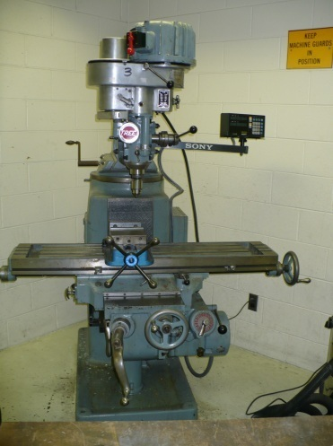

**DANGER!** Stop the machine before attempting to make measurements.

**DANGER!** Always remove the key from the chuck before turning on the drill press. It could hit something or fly out with considerable force.

The following procedures are suggested for the safe operation of a milling machine.

1. Milling machines, like all machine tools, should be cleaned after each work session. A medium width chip brush may be used to remove accumulated chips.
2. CHIPS are RAZOR SHARP; do NOT use your hand to remove them. NEVER remove chips with compressed air. The flying chips may injure you or a nearby person.
3. Become thoroughly familiar with the milling machine before attempting to operate it. When in doubt, obtain additional instruction from a proctor or the machine shop manager.
4. Wear appropriate clothing and approved safety glasses!
5. Stop the machine before attempting to make adjustments or measurements.
6. Get help to move any heavy machine attachments, such as a vise, dividing head, rotary table, or large work.
7. Stop the machine before trying to remove accumulated chips.
8. Never reach over or near a rotating cutter.
9. Be sure the work holding device is mounted solidly to the table, and the work is held firmly. Spring or vibration in the work can cause thin cutters to jam and shatter.
10. Avoid talking with anyone while operating a machine tool, nor allow anyone to turn your machine on for you.
11. Keep the floor around your machine clear of chips and wipe up spilled fluid immediately! Place special oil absorbing compound on slippery floors.
12. Be thoroughly familiar with the placement of the machine's STOP switch or lever.
13. Treat any small cuts and skin punctures as potential infections! Clean them thoroughly. Apply antiseptic and cover injury with a bandage. Report any injury, no matter how minor, to your instructor or supervisor.
14. Never "fool around" when operating a milling machine! Keep your mind on the job and be ready for any emergency!
15. Some materials that are machined produce chips, dust and fumes that are dangerous to your health. NEVER machine materials that contain asbestos, Fiberglass, beryllium and beryllium copper unless you are fully aware of the precautions that must be taken.
16. Maintain cutting fluids properly.
17. Be sure the cutter rotates in the proper direction; *normally this is a clockwise direction when looking form above*.
18. Carefully store milling cutters, arbors, collets, adapters, etc., after use. They can be damaged if not stored properly.
19. Never start a cut until you are sure there is adequate clearance on all moving parts!
20. **Never use a rag to clean the machine or part, when the spindle is in motion!**
21. Never run the machine faster that the correct cutting speed.
22. Always use cutters which are sharp and in good condition.
23. Always stay at the machine while it’s running.
24. Do NOT make heavy cuts or use the rapid feed when milling. Always refer to speed and feed tables.
25. Rig a guard or shied to prevent chips from hitting you or other people.
26. Before cleaning, remove cutting tools from spindle to avoid cutting yourself.
27. When drilling a deep hole, withdraw the drill bit quite **frequent** to clear out the chips.If the chip sticks to the drill bit use an **acid brush** to remove it.
28. Never drill with excessive pressure, only drill with enough pressure to form a clean chip that is not discolored.
29. Ease up on the drilling pressure as the drill starts to break through the backside of the material.

**DRILL PRESS SAFETY PRACTICES**

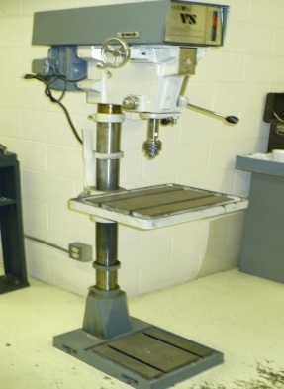**DANGER!** Always remove the key from the chuck before turning on the drill press. It could hit something or fly out with considerable force.

**DANGER!** Serious injury can result from work that becomes loose and spins about on a drill press or milling machine. If loose material spins, hold handle down with one hand and turn off the machine with the other hand.

**DANGER!** NEVER insert a tap into the drill chuck and attempt to use drill press POWER to run the tap into the work. The tap will shatter when power is applied. Turn the tap by hand!

The following procedures are suggested for the safe operation of a drill press.

1. Remove neckties and tuck in loose clothing so there is no chance of them becoming entangled in the rotating drill!
2. **Never use a rag to clean the machine or part, when the spindle is in motion!**
3. Check out the machine! Are all guards in place? Do switches work? Does the machine operate properly? Are the tools sharpened for the material being worked?
4. Clamp the work solidly on the table or in a vice. Do NOT hold work with your hand. A "merry-go-round" can inflict serious and painful injuries.
5. Wear approved safety glasses!
6. Place a piece of wood under drills being removed from the machine. Small drills can be damaged when dropped and the larger tools can injure you if dropped.
7. Use sharp tools
8. Clean chips from the work with a brush, NOT your hands!
9. Treat cuts and scratches immediately!
10. Always remove the key from the chuck BEFORE turning on the power.
11. Let the drill spindle stop on its own after turning off the power. Do NOT attempt to stop it with your hand!
12. Keep the work area clear of chips.
13. Wipe up all cutting fluid that spills on the floor right away.
14. Avoid trying to clean the tapered opening in the spindle while it is rotating.
15. After using a drill, wipe it clean of chips and cutting fluid. Replace the tool to proper storage.
16. Sheet metal, Plexiglas and other brittle plastics can be difficult to drill. Ask the shop proctor or the machine shop manager for advice on selecting the proper ground drill bits and cutting fluid selection.
17. When drilling a long piece of material place the long end of the material between your left side and the drill presses column.
18. If the drill binds in a hole, stop the machine and turn the spindle backwards by handto release the drill bit from the material.
19. Always clean the drill shank and/or drill sleeve, and spindle bore before mounting a drill chuck or tapered shank drill bit.
20. See milling section rules number 25 through 29.

**TABLE SAW SAFETY PRACTICES**

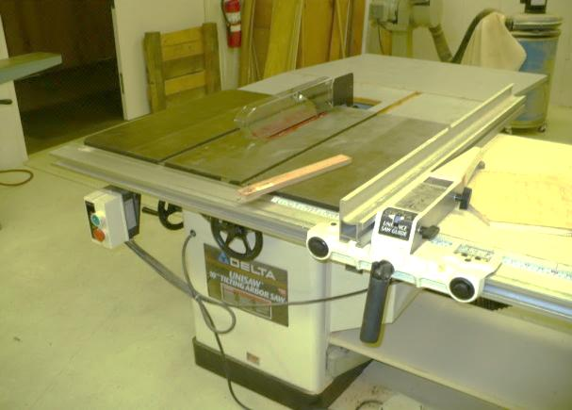

**WARNING: NEVER REMOVE GUARD**

The following procedures are suggested for the safe operation of a table saw.

1. Do not wear gloves while operating a table saw.
2. Keep the floor in front of the saw free of cut-offs and piled up sawdust.
3. Wear proper eye and hearing protection if necessary.  Wear short sleeves and remove dangling jewelry.  Stand comfortably, with your feet far enough apart for good balance.
4. Avoid any awkward operations.
5. Use a push stick to cut stock.
6. Use a stop block when you crosscut short lengths.
7. Position your body so that it is NOT in line with the blade.
8. Never reach behind or over the blade unless it has stopped turning. .
9. Always disconnect the power before changing the blade or performing any other maintenance operation.
10. Make sure that the blade has stopped turning before you adjust the table saw. .
11. Always make sure that the blade is turning free before you turn on the power: this is especially helpful after you make changes or adjustments.
12. Keep the tabletop smooth and polished.
13. Keep the rip fence parallel to the blade so stock doesn't bind on the blade and kick back.
14. Never operate a table saw with the throat insert removed.
15. Do not make free-hand cuts on a table saw.
16. Keep the blade guards, splitters and anti-kickback fingers in place and operating freely.
17. Work should be released only when it is past the blade.
18. If the piece of material that you are cutting is too large for one person to handle safely, get someone to assist you in “tailing-off” the excess material. Never try to do it alone. “Tailing-off” refers to supporting a large work-piece by supporting it underneath with your hands. **Do not grasp it, just support the vertical load.**
19. Check stock for knots, nails, screws, and any other foreign objects before cutting.
20. The blade of the circular saw should always be set to **1/8** of an inch above the work-piece to prevent kickback.
21. The fence and the miter gauge are not meant to be used together, use only one or the other.
22. Don't make adjustments to the fence when the saw is running.

**Band Saw Safety Practices**

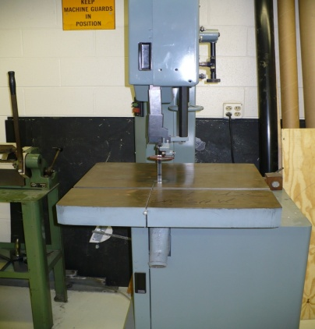

**Safety Note:** Wear safety glasses.

ALWAYS use proper blade and blade velocity.

1. The operator should be trained on the location of start stop switches or buttons.
2. Ensure that doors are closed and the blade is properly adjusted prior to turning on the machine.
3. Adjust the upper guard assembly to within 1/4" of the stop prior to starting the machine.
4. Be positive the saw blade is installed properly – teeth pointing downward toward the table – before operating machine.
5. Set the bandsaw at the appropriate speed for the type of stock being machined.
6. Check to ensure the bandsaw blade is correct for the type of stock and correct speed being used.
7. Ensure that the saw blade is sharp for cutting the stock.
8. Do not operate the machine unless all guards are in place and doors closed.
9. Always stop the machine before making adjustments.
10. Allow the saw to reach full set speed prior to cutting the stock.
11. Do not force stock into the saw blade; let the speed of the blade cut stock appropriately.
12. If the band breaks, immediately shut off the power and stand clear until the machine has stopped. Get the Shop Manager or Proctor to replace the blades.
13. Never push a piece of stock with your hands in front of the saw blade. Keep your hands at a safe distance on either side of the stock being cut.
14. Use a push stick or board to push small or irregular sized stock.
15. Be attentive to thin cut off pieces hitting the end of the slot in the insert or jamming in the slot.
16. Small work pieces can also be secured with a table top vise or clamp. All round stock should be secured in a table top vise or clamp prior to starting the cut.
17. Hold the stock flat on the table prior to starting the cut.
18. If the saw blade binds in a piece of stock, turn the saw off and wait until it comes to a complete stop before attempting to remove the blade from the stock.
19. Do not allow large quantities of chips to accumulate around the work piece after stopping the machine. Use a brush or rag to remove all excess chips from the table and stock.
20. The upper guide and guard should be set within 1/4 of an inch or as close to the work as possible.
21. Use the proper pitch blade for the thickness of the material to be cut. There should be at least two teeth per material thickness when cutting aluminum and three teeth when cutting steel.

**LATHE SAFETY PRACTICES**

**Metal Lathe**

**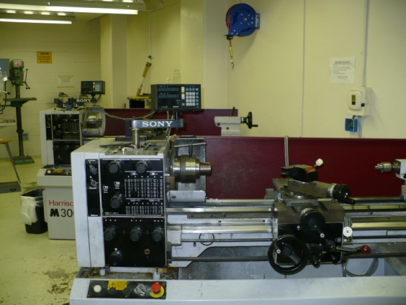**

**Eye Safety**-Wear safety glasses or safety goggles at all times in the shop! If a machine, such as a pedestal grinder or lathe, has a shield to deflect chips, it does not replace the need to wear safety glasses.

**House Keeping-**The shop floor should be kept clear of chips, debris, and pieces of material. Any fluids, such as coolant or oil, should be cleaned up immediately.

**Hand Safety**- One of the most common causes of hand injuries is contact with cutting edges. The cutting edge may be moving, which is very dangerous, but even an edge that is not moving can inflict a severe cut if you move your hand over it very fast. When operating a lathe, you should not wear anything on your hands, fingers, or forearms -- this includes long sleeves and gloves. Short sleeves should be worn in the shop, or long sleeves should be rolled up above the elbows. Gloves may be worn only when handling sharp pieces of material, and not near operating machinery. They should always be removed before any machine in the area is started. Long hair should be tied back. Also, loose clothing should not be worn.

|  |
| --- |
| **Spindle Safety** |

|  |  |
| --- | --- |
| When installing and removing chucks, face plates, and centers, always be sure all mating surfaces are clean and free from burrs. Do not use power when installing or removing chucks or faceplates on threaded spindle noses. If a chuck or faceplate should become jammed on the spindle nose, contact a proctor or the machine shop manager about removing it properly. | **http://www.wisc-online.com/objects/MTL10202/chkbar.jpg**  **Figure 4.** Use the bar technique to lift heavy chucks. |

When removing centers, be sure to handle them safely, as the point may be sharp. Use the correct knockout bar to remove the headstock center and/or sleeve. When installing or removing heavy chucks or workpieces, be sure to get help to lift them so you won't injure yourself. To help lift a chuck, place a bar of soft steel, brass, or aluminum through the chuck with enough of the bar sticking out of the back to get a good grip on it and then clamp it tight.

Now both of you can pick up the chuck and place it on the chuck board in preparation for installing it on the spindle nose. When removing it, reverse the process. Never leave a chuck key or chuck wrench in a chuck. It can be thrown out with great force and injure or kill someone. Develop the habit of never letting go of the chuck key or wrench when you are using it.

|  |  |
| --- | --- |
| To prevent axial (endwise) movement of a workpiece in the chuck, two common methods are used. The first is to use a chuck parallel, which is a three-legged piece of metal that is placed behind the work in the chuck (Figure 5).  If a four-jaw chuck is used, use a four-legged parallel. The other way is to machine a shoulder on the workpiece that will set against the chuck jaws. Either of these methods may be used to prevent the work from pulling away from the tailstock center. | **http://www.wisc-online.com/objects/MTL10202/chkprl.jpg Figure 5** Chuck parallel |

**Chip Removal**

|  |  |
| --- | --- |
| When cleaning the lathe, do not use compressed air (Figure 6). Compressed air will blow chips back into your face and eyes. Compressed air can also blow fine chips past the wipers on the machine. Fine chips between the mating surfaces of the machine will ruin the accuracy of the machine. | **http://www.wisc-online.com/objects/MTL10202/airblw.jpg**  **Figure 6.** Do not use compressed air when cleaning machines. |

Do not use your hands to remove chips. Use a pair of pliers for long chips and a brush for short chips. Long, unbroken chips are more dangerous than short broken chips because they tend to either pile up in a tangle of wiry chips around the cutting area or extend way out from it.

**Machine Operation-**Always stop the lathe to do any adjusting, measuring, cleaning, or lubricating. When it is time to stop the spindle of the lathe, there are two ways to do it. The first is to shut it off and let it coast to a stop. The other is, if the lathe is so equipped, to step on the brake treadle to stop it. Never try to stop the spindle of any machine with your hand or fingers as severe injury could result. Use brake handle and allow machine to coast to stop. Use footbrake to immediately stop machine. When changing spindle speeds by shifting gears, the lathe must be completely stopped. If the gears are difficult to mesh, turn the spindle by hand to help align the gear teeth.

**Lathe Safety Rules**

1. **Remove chuck key from chuck immediately after using**.
2. Make sure that the chuck or faceplate is securely tightened onto the lathes spindle.
3. Move the tool bit to a safe distance from the chuck, collet, or face plate when inserting or removing your part.
4. Do not run the machine faster than the proper cutting speed.
5. While setting up the tool post holder, place it to the left side of the compound slide to prevent the compound slide from running into the chuck or spindle attachments.
6. Always clamp the tool bit as short as possible in the tool holder to prevent it from breaking or vibrating.
7. Always make sure that the tool bit is sharp and has the proper clearance angles. Ask for assistance in making the proper adjustment.
8. If any filing is done on work revolving in the lathe, file **left** handed to prevent slipping into the chuck “see the lathe safety video” and **never use a file without a handle.**
9. If work is being turned between centers, make sure that the proper adjustments are made and that the tailstock is locked in place.
10. If work is being turning between centers and expands due to heat generated from cutting, readjust the center pressure to avoid excessive pressure on the centers.
11. Do not grasp or touch chips with your fingers; get rid of them using a blunt instrument. It is safest to turn off the lathe before clearing the chips from the machine.
12. Set the tool bit to the proper centerline height to prevent work from climbing over the tool bit or cutting above the centerline which causes drag between the tool bit and the material.
13. Do **NOT** cut work completely through when turning between centers.
14. Turn chuck or face plate through by hand before turning the power on, to make sure that there is no binding or clearance issues.
15. **Always stop** the machine before taking measurements.
16. Before cleaning the lathe, remove tools from the tool post and tailstock.
17. **Never use a rag to clean the machine or part, when it is in motion!**

**Wood Lathe**

**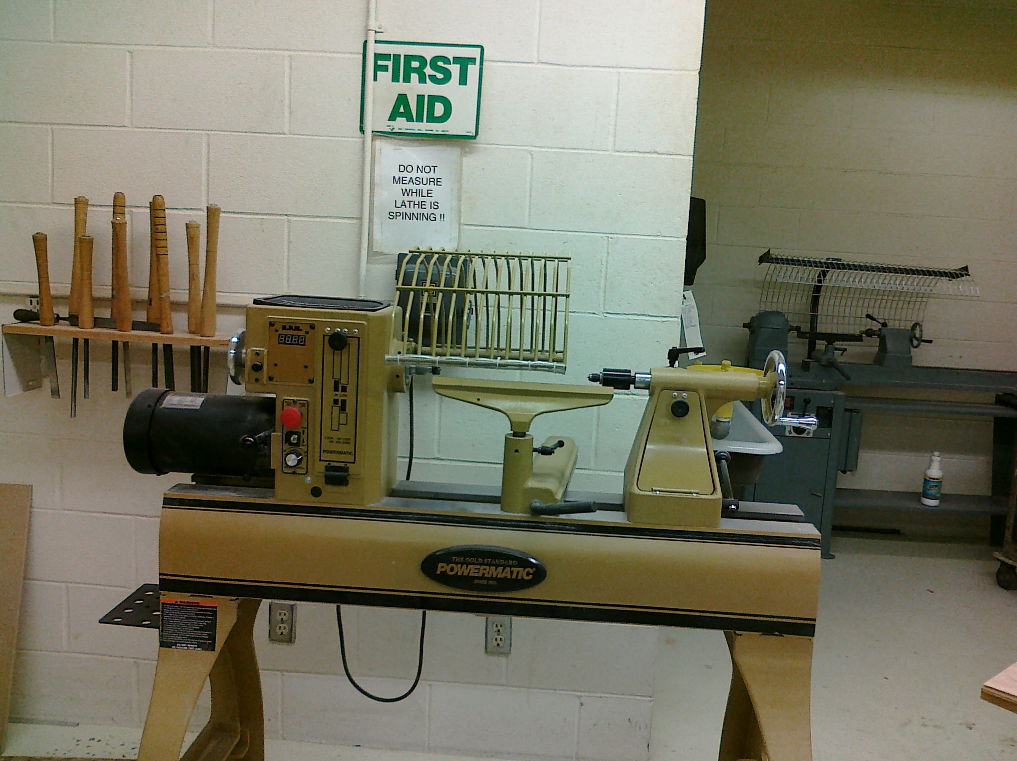**

Wood lathes are used to spin wood at a high rate of angular velocity while sharp tools are used to remove wood from the outer perimeter; this tends to throw chips and shavings through the air. Safety needs to be regarded as essential to keep the wood lathe in its safe tool category.

When thinking wood lathe safety consider four areas:

**Hands and other body parts**. In order to cut wood tools need to be sharp. As a general rule "It it will cut maple, it will cut you." Dull tools are dangerous because they slip and catch. Sharp tools will cut you if they are allowed. Never point the tool tip at yourself and always put tools away so they will not fall and hurt you nor will you put your hand on a sharp tip.

**Wear safety glasses**. Wood lathes throw shavings and chips at your face as you shape your part. Goggles are preferred to avoid dust and chips near eyes. Keep the lathe wire shield down when shaping the wood stock.

**Avoid prolonged exposure to dust.**

|  |
| --- |
| **Wood Lathe Safety Guidelines** |
| 1. Safe, effective use of a wood lathe requires study and knowledge of procedures for using the tool. Read and thoroughly understand the label warnings on the lathe and in the owner/operator's manual. 2. Always wear safety goggles or safety glasses and a full face shield when needed. Use a dust mask in dusty work conditions. Wear hearing protection during extended periods of operation. 3. Tie back long hair, do not wear gloves, loose clothing, jewelry or any dangling objects that may catch in rotating parts or accessories. 4. Check the owner/operator's manual for proper speed recommendations. Use slower speeds for larger diameter or rough pieces, and increased speed for smaller diameters and pieces that are 'true' or cylindrical. IF the lathe is shaking or vibrating, lower the speed. If the workpiece vibrates, always stop the machine to check the reason. 5. Make certain that the belt guard or cover is in place. Check that all clamping devices (locks), such as on the tailstock and tool rest, are tight. 6. Rotate the workpiece by hand to make sure it clears the tool rest and bed before turning the lathe on. Be sure that the workpiece turns freely and is firmly mounted. Never adjust the tool rest with the lathe turned on. 7. Use only defect-free stock, without cracks, splits, checks or knots which could chip and fly out, causing serious injury. 8. Hold turning chisels securely on the toolrest, and hold the tool firmly. Always use a slower speed when starting until the workpiece is cylindrical. This helps avoid the possibility of an unbalanced piece jumping out of the lathe and striking the operator. 9. When running a lathe in reverse, it is possible for a chuck or faceplate to unscrew unless it is securely tightened on the lathe spindle. 10. It is recommended that you rough out your workpiece on a bandsaw before mounting it on the lathe. 11. When using a faceplate, be certain the work piece is solidly mounted. When turning between centers, be certain the work piece is secure. 12. Always remove the tool rest before sanding or polishing operations. 13. Don't over-reach, keep proper footing and balance at all times. 14. Keep lathe in good repair. Check for damaged parts, alignment, binding of moving parts, and other conditions that may affect its operation. 15. Keep tools sharp and clean for better and safer performance. Don't force a dull tool. Don't use a tool for a purpose not intended. 16. Consider your work environment. Don't use lathe in damp or wet locations. Do not use in presence of flammable liquids or gases. Keep work area well lit. 17. Stay alert. Watch what you are doing, use common sense. Don't operate tool when you are tired, or under the influence of drugs or alcohol. 18. Remove chuck keys and adjusting wrenches. Form a habit of checking for these before switching on the lathe. 19. Never leave the lathe running unattended. Turn power off. Don't leave the lathe until it comes to a complete stop. 20. Be sure to allow laminated, or glued-up, blanks to dry thoroughly before turning. 21. Make certain that the work is secure before you start turning operations. Frequently check it as you continue working on the wood. Position the tool rest 1/8 to ½ of an inch away from the stock. After adjusting the chuck, remove the chuck wrench immediately. Make sure all the guards are in place around the rotating heads of the lathe before operations begin. 22. Never use your fingers to check the work for roundness while the lathe is running, especially during roughing operations. Stop the lathe to check the progress, or *by resting the back side of the chisel lightly against the top of your work piece while it is still in motion* 23. Do not use a dead center on the tailstock. A dead center, which does not turn, creates friction and may burn the work, damaging the product and creating potential hazards. 24. Wear a dust mask when performing sanding operations. |

**Pedestal Grinder Safety Practices**

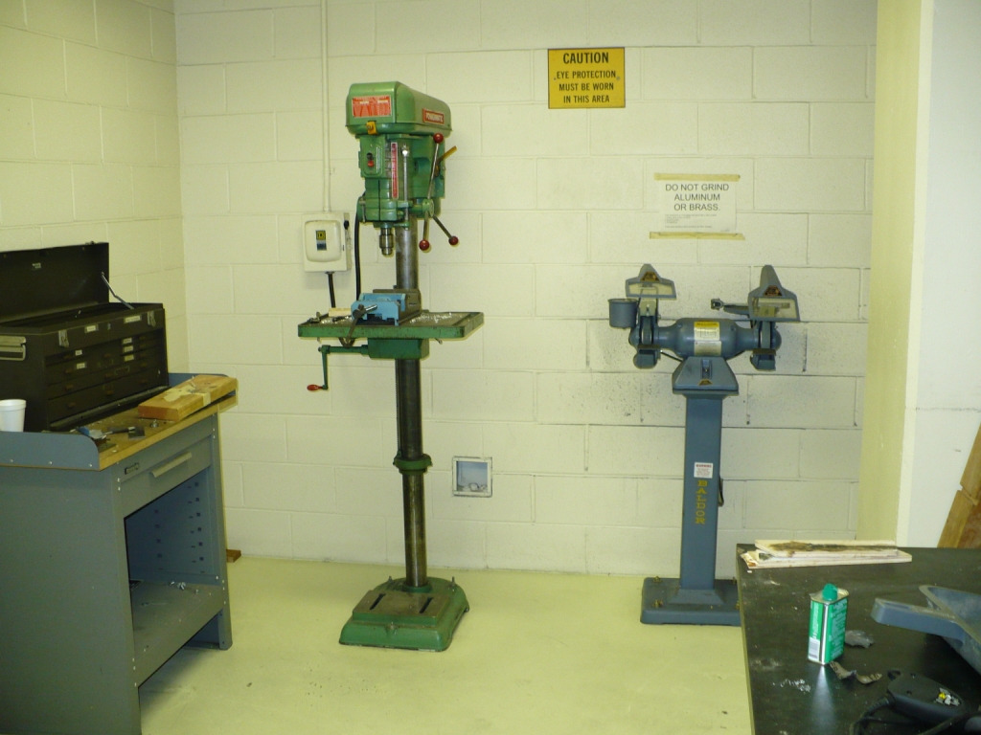

**WARNING**: Wear safety glasses. Use a dust mask for prolonged operations (see proctor or the shop manager for masks)

1. Use the safety guards and tool rest.
2. Inspect the wheels before turning on the power. Do not use wheels that have been chipped or cracked, even though there may be no apparent damage. Such wheels may have internal fractures and will disintegrate upon startup.
3. Clean the machine thoroughly when processing different types of work pieces. DO NOT GRIND SOFT MATERIALS (wood, aluminum, brass – use the belt sander)
4. Stand to one side of the wheel while turning on the power.
5. Keep the tool rest as close to the grinding wheel as possible without touching the wheel. The tool rest must be minimally within 1/8" of the grinding wheel.
6. Prior to starting the grinder, ensure guards enclosing the outside of grinding wheel are in place.
7. Adjust eye shields close to the grinding wheel, and re-adjust as the wheel wears down.
8. Be alert and cautious when a grinding operation requires putting your fingers close to the wheel.
9. Feed the stock into the wheel with light to medium pressure, do not force the piece.
10. Do not use the side of the grinding wheel to shape stock. Grind a workpiece using the face of the grinding wheel only.
11. Stand erect in front of the grinder with both legs straight and slightly apart. Avoid stooping or leaning into the machine.
12. Do not touch the ground portion of a workpiece until it has cooled sufficiently.
13. Hold work securely while grinding, use the tool rest to support your work when performing any grinding operations on a bench or pedestal grinders.
14. Keep the grinding wheel dressed. Dressing a small amount frequently is better than having to dress a lot later and will allow the wheel to cut faster, cooler, and with a better surface finish. Dressing is cleaning and smoothing the surface of the grinding wheel.

**Belt Sander Safety Practices**

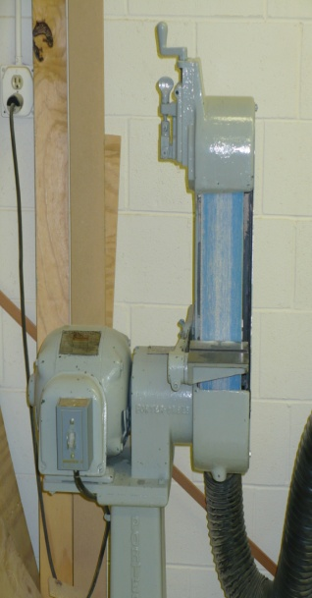

**WARNING**: Watch where you place your hand to avoid knuckle running into spinning disc.

* 1. Use the safety guards and tool rest.
  2. Never turn the machine on before clearing the table/work area of all objects (tools, scraps of wood, etc.).
  3. Never turn the machine on with the workpiece contacting the abrasive surface.
  4. Inspect the belt for rips and tears. Notify the proctor if the belt needs to be replaced.
  5. Avoid kickback by sanding in accordance with the directional arrows. Feed the workpiece against the downward rotation side of the disk or the forward rotation of the belt with moderate pressure.
  6. Do not sand very small or very thin work pieces that cannot be safely controlled
  7. Properly support long or wide work pieces.
  8. Do not use gloves when hands are close to belt.

**Metal Forming Tools – Safety Practices**

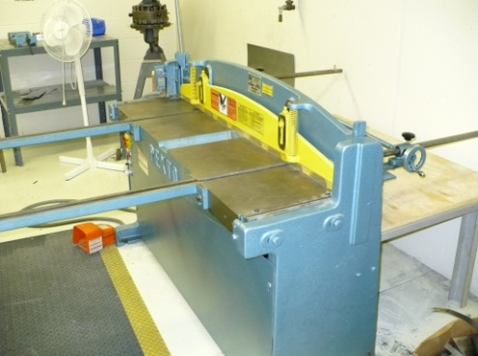

**Corner Notcher**

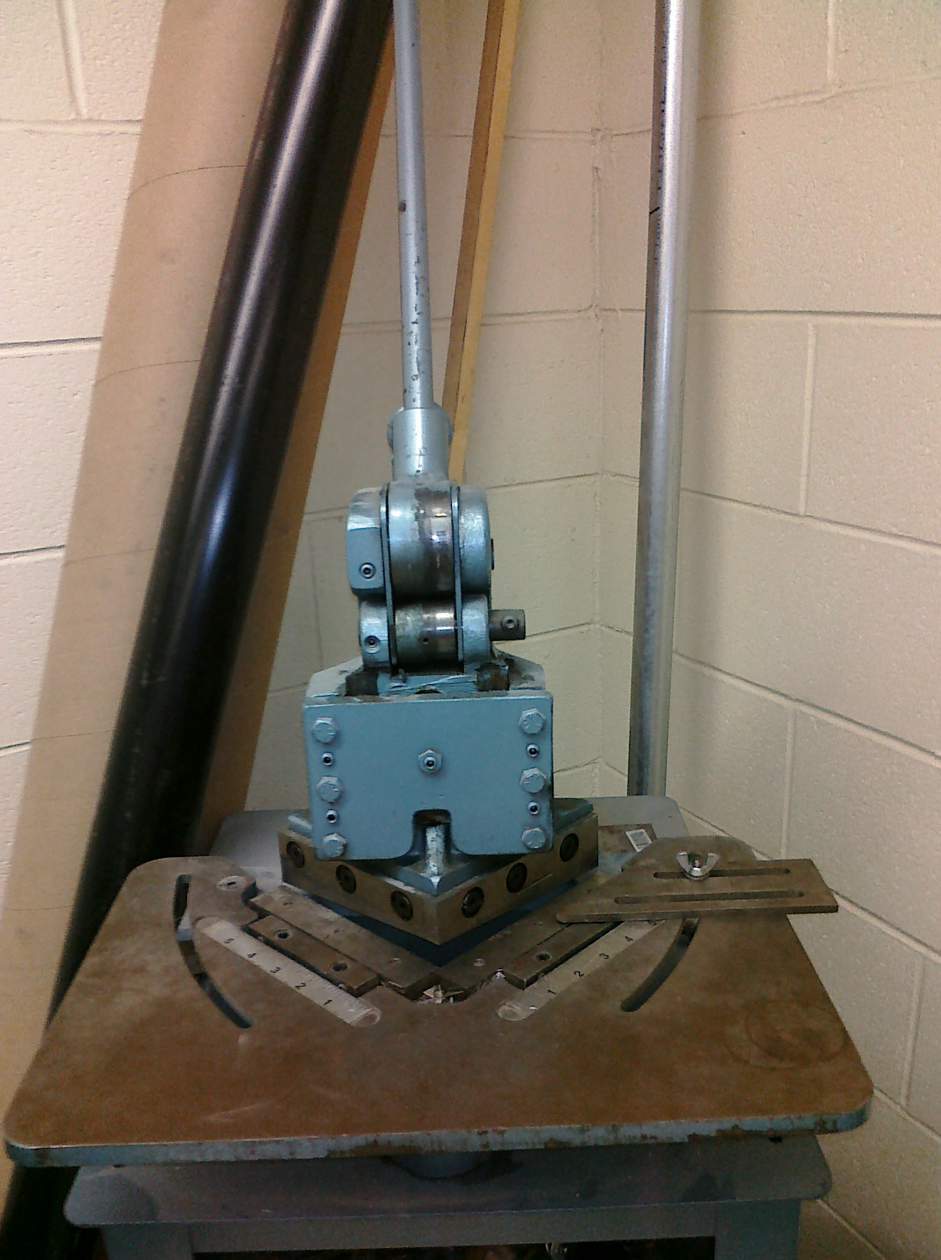

**Sheet Metal Shear**

1. Ensure that the shear, corner notcher, and hole punch is rated to cut the gauge of sheet metal you’re working with, or you may damage the equipment.
2. Insure blade guard is in place
3. Keep fingers back away from the clamp and blade
4. Sheet stock should be placed on the table of the sheet metal shear and slid below the Plexiglass shield. When stock is oriented properly, make a cut by stepping down on the hydraulic foot pedal.
5. Use extreme caution when removing metal from the scrape tray.
6. Keep persons way from backside of shear when using

**Metal Benders**

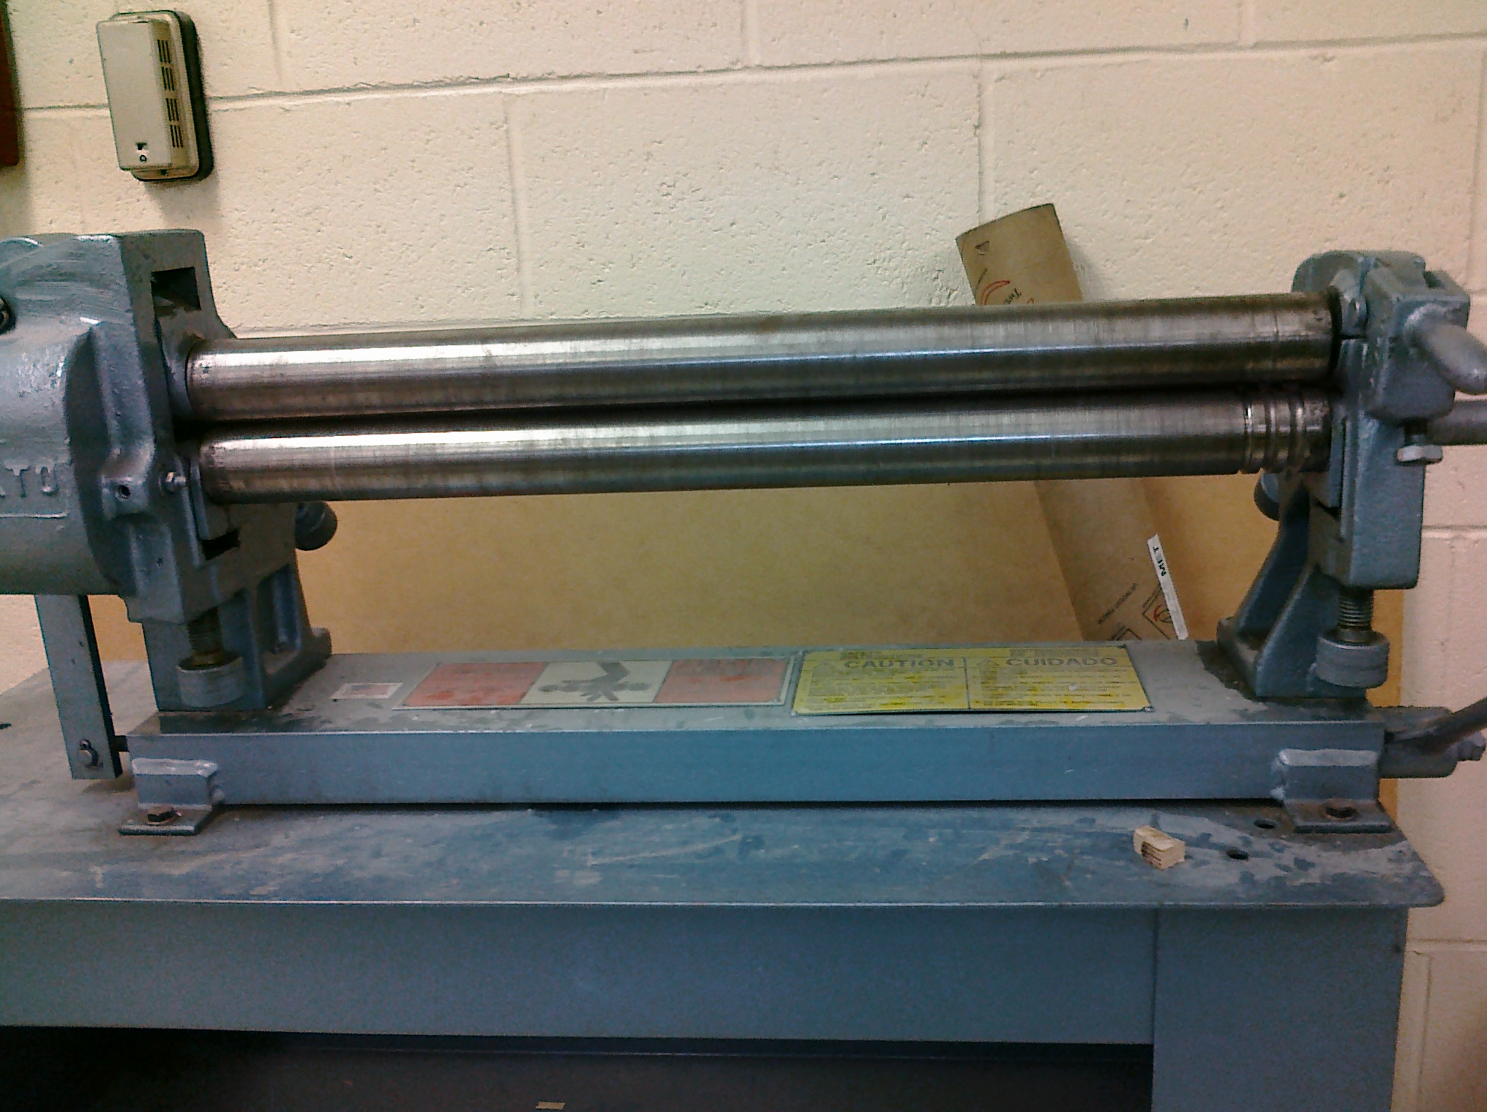

1. The work must be slid under the shoes. Raise the shoe with the elevation levers, slide the work in place, and lower the shoes back down. The radius of the bend can be set with the adjustments
2. Bend the work by applying force to the bending levers.
3. Keep persons from reaching into the die area. When operating the bender, weighted levers move at the same time.
4. When operating the Roller, do not wear loose long sleeves, jewelry or other articles of clothing that could become entangled. Keep fingers clear.

**Heat Treatment**

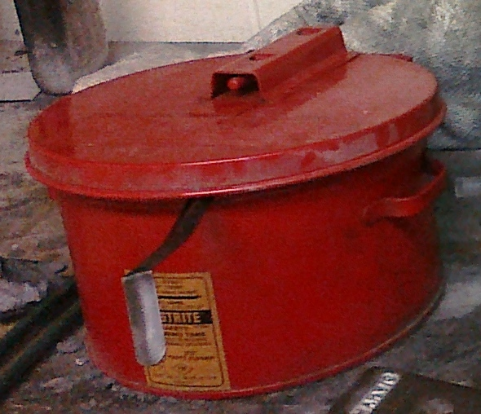

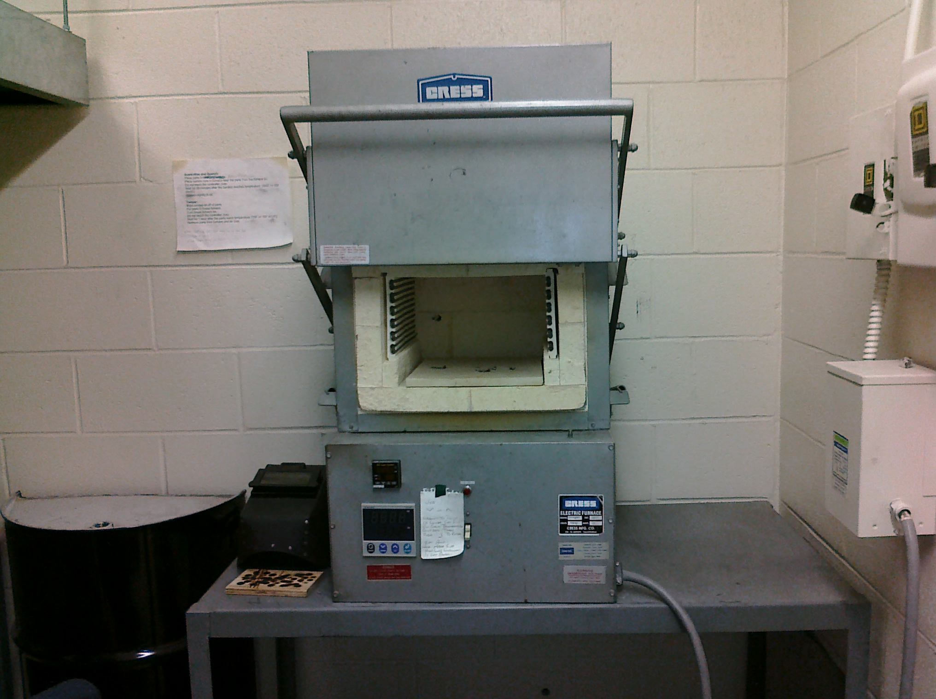

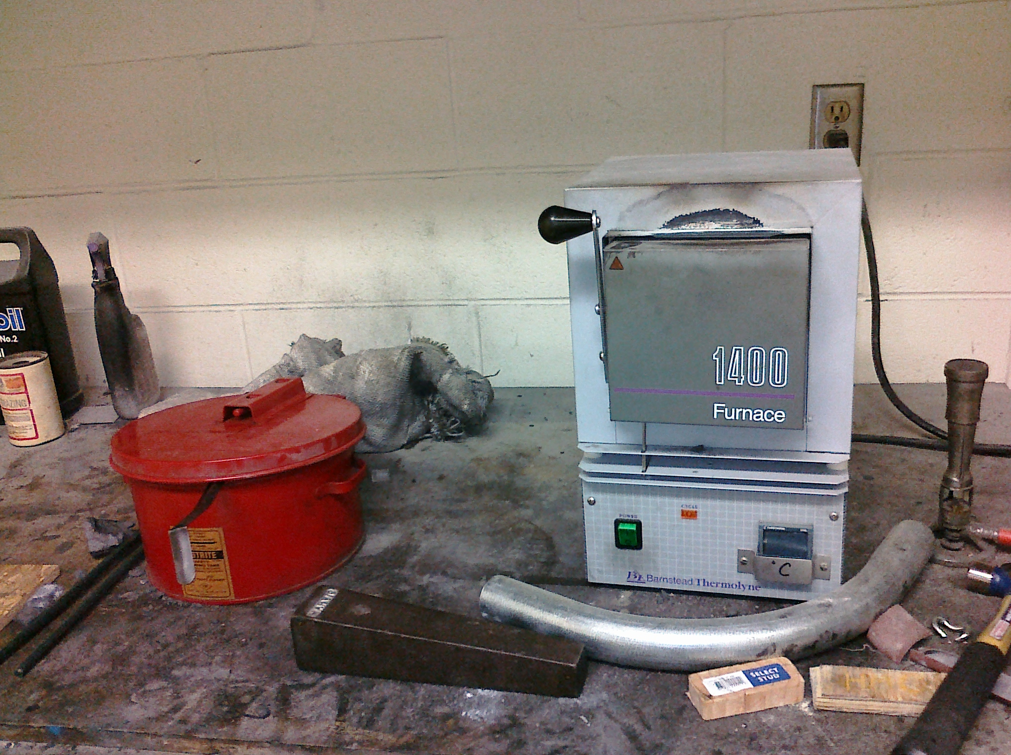

Heat-treating operations require a quench as an integral part of the process. Liquid quenches normally involve the use of mineral oils, water-based solutions or molten salt. Less severe quenches use circulated gases or forced air, or involve cooling in still air. Quenching operations pose various health hazards to workers. These include working in high temperatures and the risk of fire or explosion

**General Safety for Heat Treatment operations**

1. Wear safety glasses, gloves and if necessary, heat-resistant protective clothing when working with hot metal. Quench oils may be very hot (above 100C) and oil temperature increases during quenching. Splashes or skin contact cause burns. Avoid skin contact with oils by using gloves and protective clothing.
2. Check that all safety devices, such as automatic shut-off valves, air switches, and exhaust fans are working properly before lighting the furnace.
3. Ensure that quenching areas have enough ventilation to keep oil mists at recommended levels.
4. Follow the manufacturer's instructions when lighting the furnace.
5. Stand to one side when lighting a gas- or oil-fired furnace.
6. Ensure that water does not contaminate the quenching oil. Any moisture which comes in contact with the oil can cause an explosion.
7. Use the proper tongs for the job and make sure the tongs are dry before removing any work from a liquid carburizing pot.
8. Ensure that a suitable bacterial inhibitor or fungicide has been added to the quenching liquid.
9. Cover quench tanks when not in use.
10. Clean up oil spills and leaks immediately using a nonflammable absorbent.
11. Keep work areas, jigs, baskets and tools free from oil contamination where possible.
12. Wash hands thoroughly after work before starting other tasks.
13. Obtain first aid for all cuts and abrasions. Protect them from contamination by using suitable dressings.

**Additional considerations:**

1. Do not inhale the fumes from a molten carburizing salt bath. During the carburizing process, carbon monoxide is generated. Ensure that this area is well ventilated. These molten salt baths may contain potassium or sodium cyanide, a deadly poison. Handle the salt mixture with caution and watch for contamination from carburized metal pieces.
2. Do not wear oil-soaked clothing or put oily rags in your pockets.
3. Do not bring food or drink into areas where quench oils are stored or used.
4. Do not wear or take oil-contaminated clothing or equipment into areas where food or drink are consumed

**Welding Safety Practices and Guidelines**

**Notice:** Welding equipment is not allowed out of shop area and can only be used during hours when the Shop Manager is available.

**Always use an exhaust system**

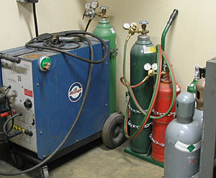

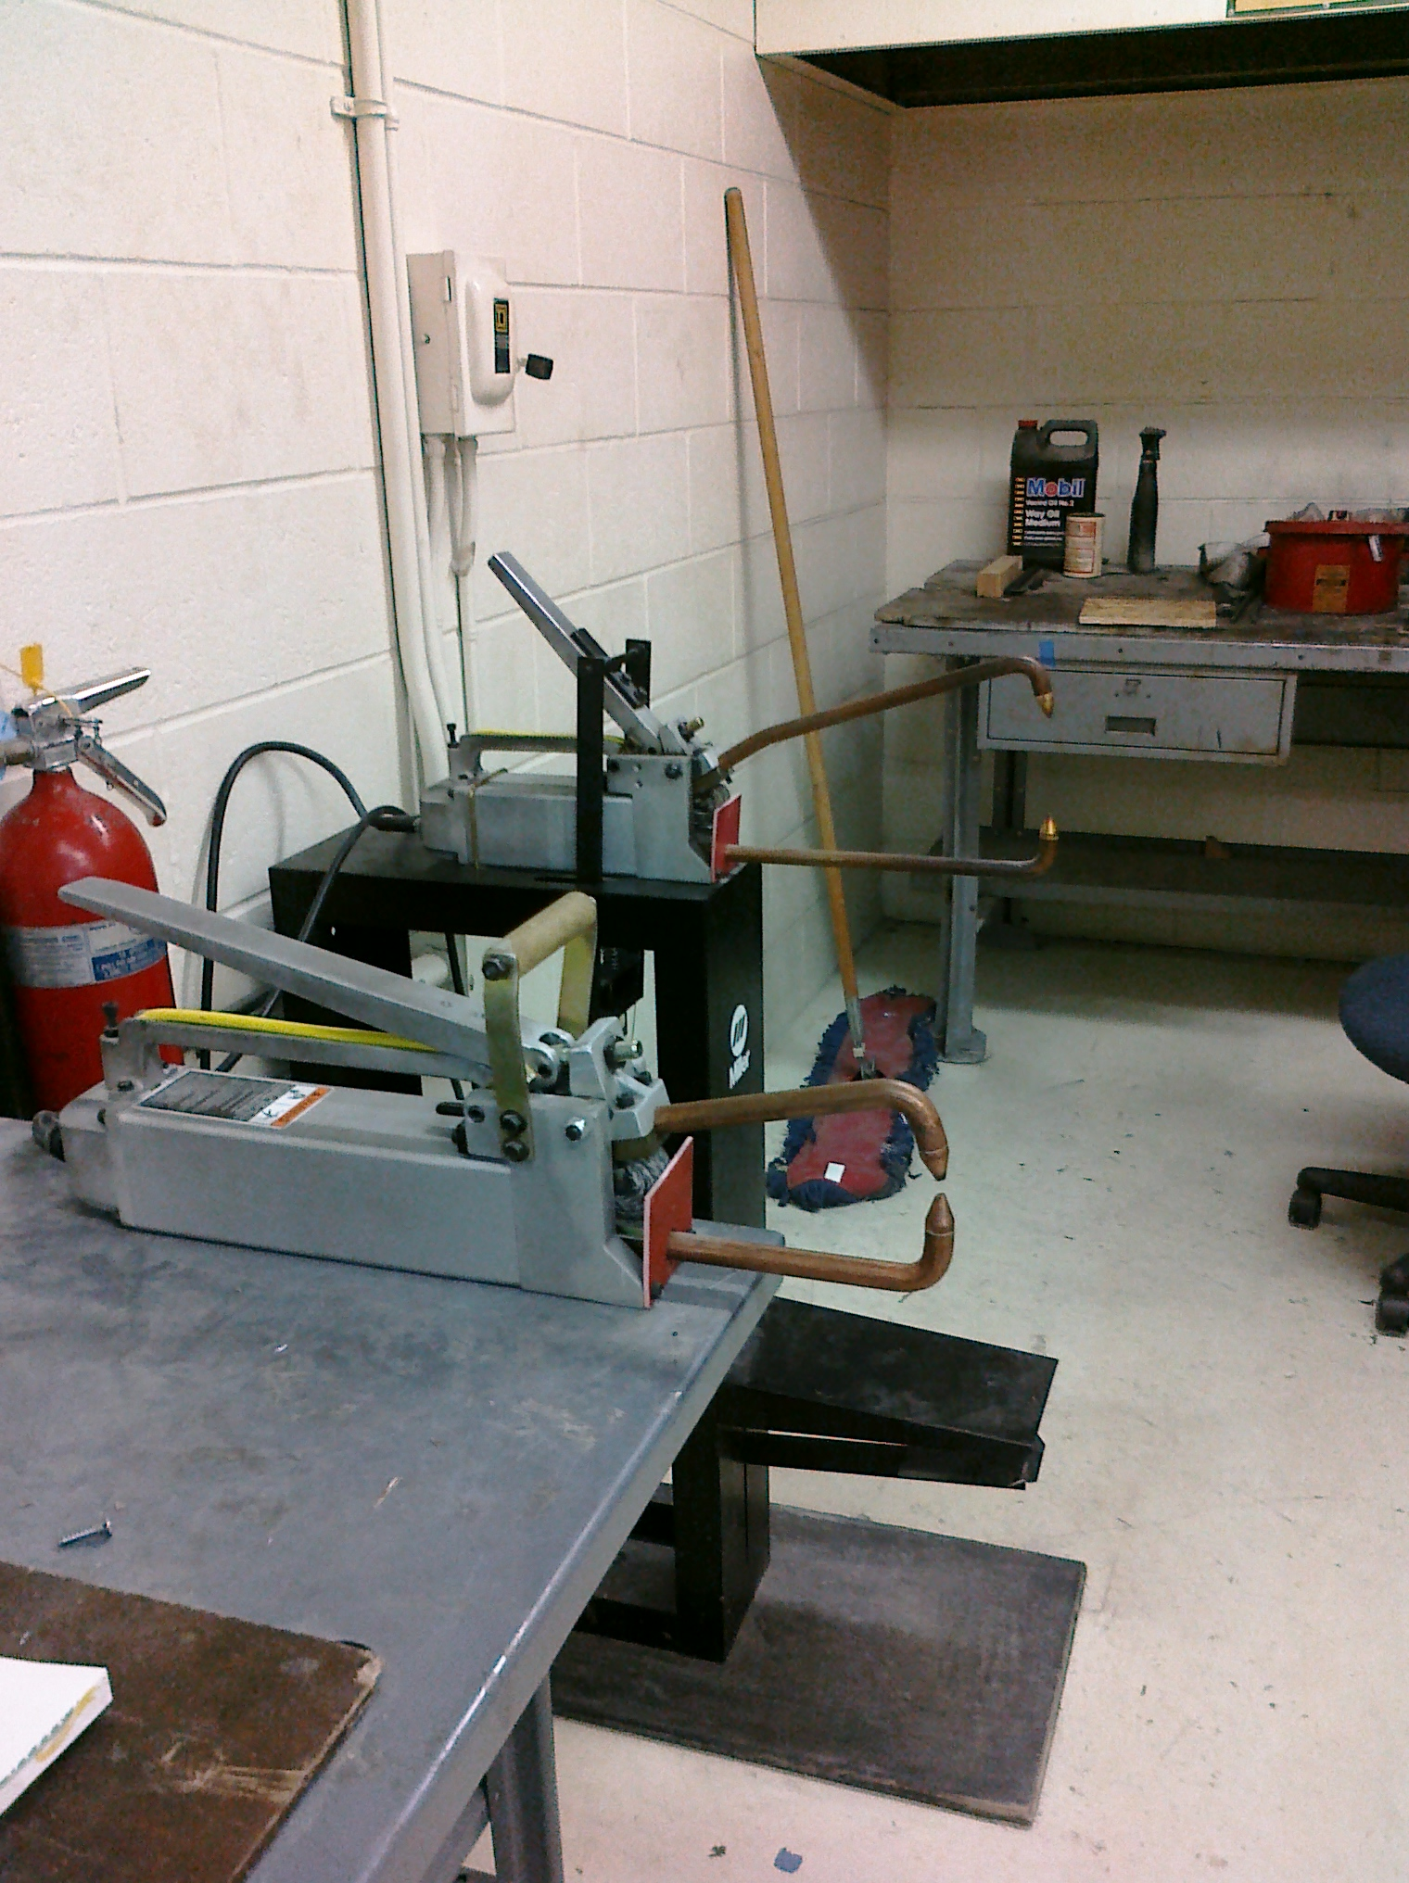

**Welding Equipment**

**Spot Welders**

1. **Machine Shop manager approval is required before using any welding equipment**
2. Welders and anyone else in the welding area must wear safety glasses or helmets of recommended shades during welding operations.
3. The welder is responsible for erecting a curtain around the welding area to protect others from eye injury.
4. Inspect all welding equipment to be used prior to each use for possible damage
5. Avoid handling oxygen cylinders with greasy hands, gloves or rags. Fatal explosions have resulted fro this cause. Do not store or use oil around gauges
6. Always double strap cylinders to a weld cart or a fixed object. Never allow a gas cylinder to be free standing. Replace the safety cap on all cylinders when not in use.
7. When arc welding, make sure work and/or work table is properly grounded
8. Do not arc weld in a wet area
9. Be alert to possible fire hazards. Move the object to be welded to a safe location, or, remove all flammables from the work area.
10. Never weld in the same area where degreasing or other cleaning operations are performed.
11. Keep suitable fire extinguishing equipment nearby and know how to operate it.
12. Shut off the cylinder valves when the job is completed; release the pressure from the regulators by opening the torch valves. Never leave the torch unattended with pressure in the hoses.
13. Utilize all protective equipment and clothing. Do not arc weld with any part of the body uncovered. The arc light is actinic light (excessive ultraviolet) and will cause burns similar to severe sunburn. The shop manager will provide protective jacket and sleeves.
14. Welders are **prohibited** to wear any contact lens, doing so may cause blindness.
15. Never weld inside drums or enclosed spaces without adequate ventilation.
16. Check the ventilation system before starting to weld and periodically thereafter to ensure adequate performance. Welding fumes should not be allowed to get into the rest of the shop working areas.
17. Never cut or weld any container that has held explosive or flammable materials. Use prescribed methods for cleaning or flooding.
18. Never use wrenches or tools except those provided or approved by the gas cylinder manufacturer to open cylinder valves. Never use a hammer to open or close valves.
19. Abide by any other safety measures required for each particular type of welding
20. Allow for proper ventilation when brazing or soldering. The fluxes are acidic and toxic.
21. Do not weld on painted, galvanized or greasy, oily metals. Not only can the fumes be toxic, but the welds will not be satisfactory and will fail in use. Galvanized metals produce hazardous gases. Weld galvanized metals under shop manager supervision.

**Safety Rules for the Jointer**

**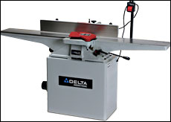**

1. The maximum depth of cut on the jointer is 1/8”, do not exceed this amount.
2. The cutterhead should be guarded with a spring loaded, self-closing guard that adjusts to the size of the stock.
3. Lock the fence into position before using the jointer.
4. Always use hold down or push blocks for jointing material narrower the 3” or planning material thinner than 3”.
5. Never joint or plane material less than 10” long.
6. Always keep hands and fingers away from cutterhead.
7. Disconnect machine from power source before making adjustments.
8. No gloves, neckties, jewelry, or loose clothing is allowed near any machinery.
9. Stock that has loose knots, splits, and/or structural defects in it should never be jointed.
10. Stand to one side of the machine, not directly in front of the jointer.
11. Do not leave the jointer until the cutterhead has come to a complete stop.
12. Return the depth of cut to 1/32” when you are finished with the jointer. You, or the next operator, could be seriously injured if the jointer is set for a deep cut as kickbacks occur when the depth of the cut is deep.
13. Make sure that there are no nails or screws in the work piece.
14. **Clean up the work area.**

### Harvey Mudd College General Machine Shop Rules

**Shop User Agreement**

Misuse of the machines and tools in the various shops may cause injury or death. The following rules must be followed by ***all*** shop users.

1. **Complete and pass the safety test before working in the shops.**
2. **There must be a proctor on duty to work in any of the shops.**  
   The proctor may be in a different shop. The shop manager may also serve as a replacement for the shop proctor from across the hall but you must check in with him or her first.
3. **Do not use machines that you do not know how to use.**  
   If you want to use something, and you don't know how. Ask a shop proctor or the machine shop manager for training and safety issues.
4. **Do not wear long sleeves or loose clothing. Tie loose hair.**  
   It may get caught in rotating machinery.
5. **Wear closed-toed shoes.**
6. **Wear safety glasses.**  
   Wear safety glasses or goggles whenever present in the shops, this holds true whether the machines are running or not. Ordinary eye-glasses are **not** acceptable, you must use over the glasses safety glasses or goggles over your prescription glasses.
7. **Report all broken tools and machines.**  
   A note on the white-board is not sufficient. Tell a shop proctor or the shop manager.
8. **If an oven is on, at least two people must attend to it.**
9. **Do not use the arc welder while wearing contact lenses.**
10. Material Safety Data Sheets must be supplied on chemicals, solvents and other materials. Review the MSDS with the Shop Manager or Proctor before work begins.
11. **Clean your machine.**  
    Brush the chips off of the chuck/vice, bedways, tables, and surrounding equipment. SWEEP up your area as well.
12. All metal scrap and cuttings are to be disposed of in the proper recycling drum.
13. Do not put trash or metals of unknown composition into the recycling drum.
14. **Report all near misses and accidents to the shop manager or shop proctor**
15. No arguing or horseplay in the shop
16. **Be sober!**  
    Do not come to the shop for any reason under the influence of any drug. (Alcohol is a drug, too.)

I understand that I must follow all the above safety regulations when working in the HMC

machine shop

**Shop User Signature \_\_\_\_\_\_\_\_\_\_\_\_\_\_\_\_\_\_\_\_\_\_\_\_\_\_\_\_\_\_\_\_\_\_\_\_\_\_\_\_ Date\_\_\_\_\_\_\_\_\_\_\_**

**Print Name (legibly) \_\_\_\_\_\_\_\_\_\_\_\_\_\_\_\_\_\_\_\_\_\_\_\_\_\_\_\_\_\_\_\_\_\_\_\_\_\_**

**Approved By \_\_\_\_\_\_\_\_\_\_\_\_\_\_\_\_\_\_\_\_\_\_\_\_\_\_\_\_\_\_\_\_\_\_\_\_\_\_\_\_\_\_\_\_**

**Date \_\_\_\_\_\_\_\_\_\_**